**Project Management Excellence**

Seventh Edition

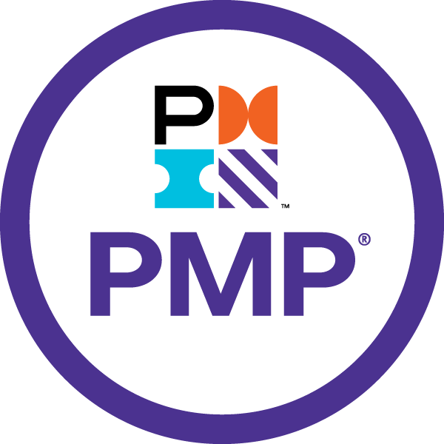

Sriram

# Sriram

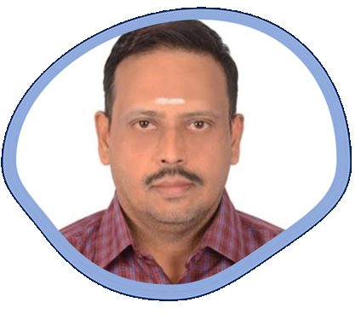

I have been involved in IT Software development since 1997. I have unique combination of process, technical and industrial skills. As a Digital Leader, I have expert level of knowledge in agile and practices with this combination I can help process and technology people, understand the agile world.

The “**Project** **Management Excellence – 7th Edition”** book comprises of Traditional Project Management with Agile.

My agile journey started in 2011, when I was a part of Tata Consultancy Services. I practiced scrum and agile methods thoroughly over several years and my teams are highly successful in delivering products using agile techniques.

I am proficient in agile engineering, coaching practices and SAFe consulting practices. I have more than 5 years of experience as a senior architect cum senior manager in development. I religiously follow key agile engineering practices like TDD, Refracting, CI and Collective Ownership. Worked in USA, UK for TCS, AtoS, Cognizant & IBM - Agile customers, which creates a global agile experience.

I moved back to India in 2016 and created agile websites and released books related to Scrum Alliance Professional, Agile Coaching and Implementing SAFe 5.0 practices.

Throughout my agile journey, I have been associated the agile professionals, who have helped and mentored me in the journey where sky is the limit.

Place: Dubai, UAE – Middle East Email: intellectsriram@gmail.com

# Table of Contents

Contents

Sriram 2

Table of Contents 3

Project Management 7th Edition 4

The Standard for Project Management 7

Section 1 Introduction 7

Section 2 Value Delivery System 11

Section 3 Project Management Principles 14

A Guide to the Project Management Body of Knowledge 27

Section 1. Project Performance Domains 28

1.1 Stakeholders Performance Domain 29

1.2 Team Performance Domain 31

1.3 Development Approach and Life Cycle Performance Domain 35

1.4 Planning Performance Domain 37

1.5 Project Work Performance Domain 39

1.6 Project Delivery Performance Domain 41

1.7 Measurement Performance Domain 43

1.8 Uncertainty Performance Domain 46

Section 2. Tailoring 48

Section 3. Tailoring Models, Methods & Artifacts 58

# Project Management 7th Edition

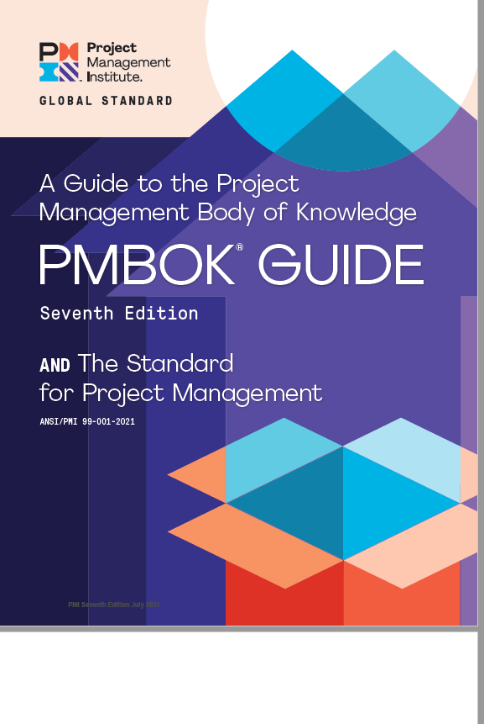

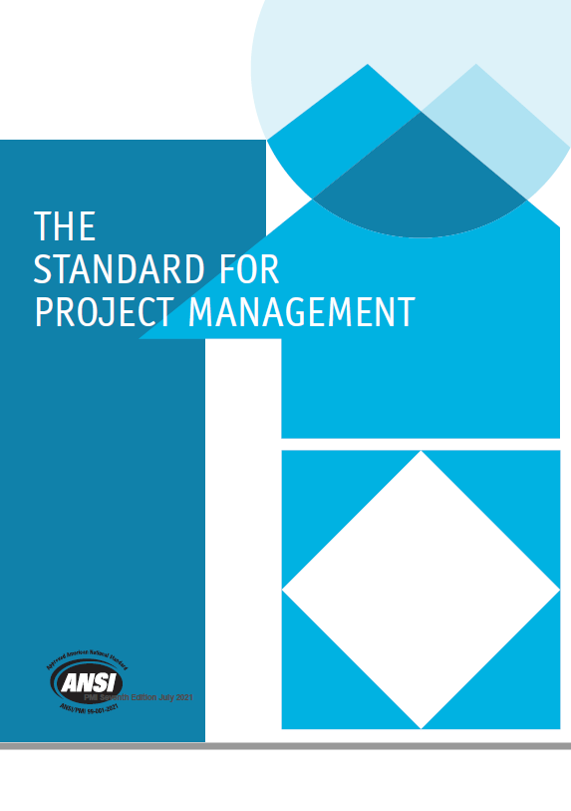

*The Standard for Project Management* provides a basis for understanding project management and how it enables intended outcomes. This standard applies regardless of industry, location, size, or delivery approach, for example, predictive, hybrid, or adaptive. It describes the system within which projects operate, including governance, possible functions, the project environment, and considerations for the relationship between project management and product management.

*The Standard for Project Management* consists of the following sections:

Section 1 Introduction

Section 2 A System for Value Delivery

Section 3 Project Management Principles

# The Standard for Project Management

### Section 1 Introduction

**What is a PMBOK Guide?**

A Guide to the Project Management Body of Knowledge (PMBOK® Guide) – Seventh Edition and The Standard for Project Management which get released on August 1, 2021. PMI actively involves stakeholders around to understand what is happing in the field of project management.

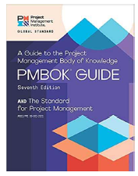

**Share PMBOK Edition Comparison? What are its changes?**

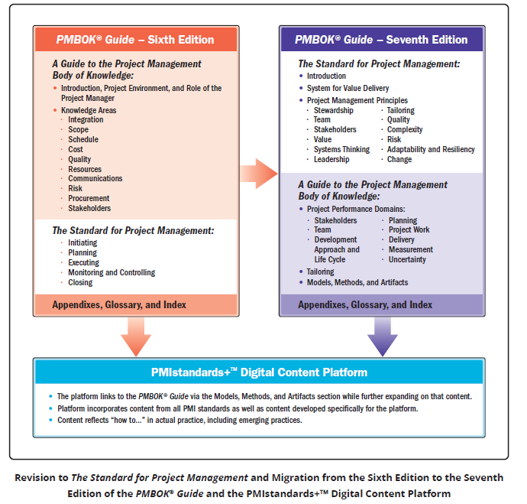

**Terms in Project Management**

**What is Project?**

A Project is a temporary endeavor undertaken to create a unique product, service or result in your organization.

**What is Product?**

An artifact that is produced, is quantifiable, and can be either an end item in itself or a component item.

**What is Operation?**

Day-to-day work within an organization to accomplish the goals of the organization.

**What is Program?**

Related projects, subsidiary programs, and program activities that are managed in a coordinated manner to obtain benefits not available from managing them individually.

**What is Portfolio?**

Projects, programs, subsidiary portfolios, and operations managed as a group to achieve strategic objectives

**What is Outcome?**

An end result or consequence of a process or project.

**What is Project management?**

The application of knowledge, skills, tools, and techniques to project activities to meet project requirements.

**What is Project Manager?**

The person assigned by the performing organization to lead the project team that is responsible for achieving the project objectives.

**What is Project team?**

A set of individuals performing the work of the project to achieve its objectives.

**What is System for value delivery?**

A collection of strategic business activities aimed at building, sustaining, and/or advancing an organization.

**What is Value?**

The worth, importance, or usefulness of something.

**What are the principles of Project Management? & What are the Project Performance Domains? What is the relationship between them?**

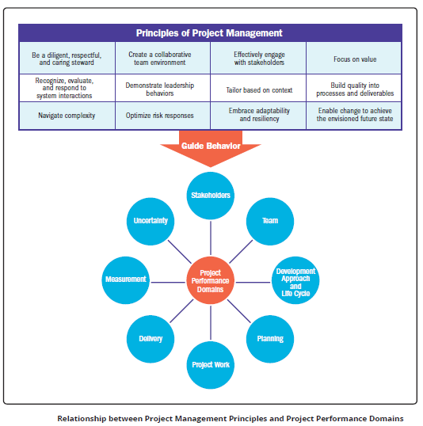

A project performance domain is a group of related activities that are critical for the effective

delivery of project outcomes. Project performance domains are interactive, interrelated, and

interdependent areas of focus that work in unison to achieve desired project outcomes. There are

eight project performance domains:

* Stakeholders
* Team
* Development Approach and Life Cycle
* Planning
* Project Work
* Delivery
* Measurement
* Uncertainty

### Section 2 Value Delivery System

**Creating Value**

* Projects exist inside a larger system, such as a governmental agency, organization, or contractual arrangement.
* Project can:
  + Creating a new product, service, or result
  + Creating positive social or environmental offerings
  + Improving efficiency or productivity
  + Enabling the changes within an organization

**Value Delivery Components**

There are various components, such as portfolios, programs, projects, products, and operations, that can be used individually and, in a group, create value.

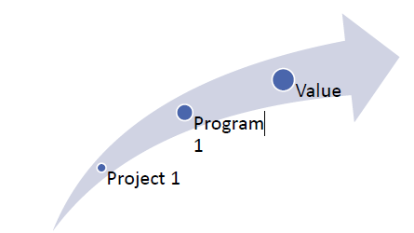

**Information Flow**

* Value delivery systems works best with information is effectively flowing between different components.
* For example, senior managers to portfolios to programs to project to operations.

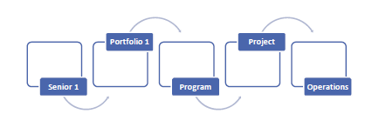

**Organizational Governance Systems**

* Governance system works together with the value delivery system to enable smooth workflows, manage issues, and support decision making.
* Governance systems deliver a framework with functions and processes that guide activities.
* A governance framework can comprise of elements of oversight, control, value assessment, integration among components, and decision-making capabilities.

**Functions Associated with Projects**

* People conduct project delivery.
* They do so by doing functions necessary for the project to run effectively and efficiently.
* Functions related to the project can be fulfilled by one person, by a group of people,or combined into defined roles.
* Coordinating a collective work effort is extremely important to the success of any project
* Provide oversight and coordination
* Present objectives and feedback
* Facilitate and support
* Perform work and contribute insights
* Apply expertise
* Provide business direction and insight
* Provide resources and direction
* Maintain governance

**The Project Environment**

Internal and external environments can influence planning and other project activities.

**Internal**

* Factors internal to the organization can arise from the organization itself, a portfolio, program, another project, or a combination of these.
* Includes: Process assets, data assets, infrastructure, resource availability, employee capability

**External**

* Factors external to the organization can enhance, constrain, or have a neutral influence on project outcomes
* Includes: Marketplace conditions, Regulations, Industry standards, physical environment

**Product management considerations**

**Product Management:** “Product management is an organizational function within a company dealing with new product development, business justification, planning, verification,

forecasting, pricing, product launch, and marketing of a product or products at all stages of the product lifecycle” -**Wikipedia**

Product management may initiate programs or projects at any point in it’s life cycle to create or enhance specific components, functions, or capabilities

While product management is a separate discipline, it represents a key integration point within the program management and project management disciplines.

### Section 3 Project Management Principles

**What are the Principles of Project Management?**

* Principles serves as foundational guidelines for strategy, decision making, and problem solving
* Professional standards and methodologies are often based on principles
* Principles for project management provide guidance for the behavior of people involved in projects

**What is the PMI Code of Ethics and Professional Conduct?**

* Principles can, but do not necessarily, reflect morals.
* A code of ethics is related to morals.
* A code of ethics for a profession can be adopted by an individual or profession to establish expectations for moral conduct.
* PMI is based on four values: -
* Responsibility
* Respect
* Fairness
* Honesty

**Compare Project vs. General Management Principles?**

Principles of project management can also have areas of overlap with general management principles

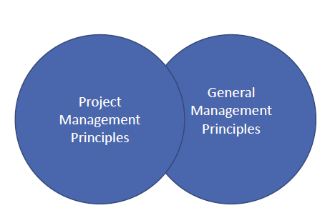

**What are the 12 Principles of Project Management?**

1. Be a diligent, respectful, and caring steward

2. Create a collaborative project team environment

3. Effectively engage with stakeholders

4. Focus on value

5. Recognize, evaluate, and respond to system interactions

6. Demonstrate leadership behaviors

7. Tailor based on context

8. Build quality into processes and deliverables

9. Navigate complexity

10. Optimize risk responses

11. Embrace adaptability and resiliency

12. Enable change to achieve the envisioned future state

**1. Be a Diligent, Respectful, and Caring Steward**

* STEWARDSHIP: “The act of taking care of or managing something, for example property, an organization, money or valuable objects.” - https://www.oxfordlearnersdictionaries.com/
* Stewards act sensibly to carry out actions with integrity, care, and trustworthiness while keeping
* compliance with internal and external guidelines
* They demonstrate a broad commitment to financial, social, and environmental impacts of the projects they support. Stewardship has responsibilities both within and external to the company.
* Stewardship includes:
* **Integrity** -> Stewards behave honestly and ethically
* **Care** -> Stewards are fiduciaries of the organizational matters in their charge, and they diligently oversee them.
* **Trustworthiness** -> Stewards represent themselves, their roles, their project team, and their authority accurately, both inside and outside of the organization.
* **Compliance** -> Stewards comply with laws, rules, regulations, and requirements.
* A holistic view of stewardship considers financial, social, technical, and sustainable environmental awareness.

**2. Create a collaborative project team environment**

**Team**

* Projects are done by project teams
* Project teams are made up of people who have diverse skills, knowledge, and experience
* Project teams that work collaboratively can finish a shared objective more effectively and efficiently than individuals working on their own
* Project teams work within organizational and professional cultures and guidelines, often establishing their own “local” culture.
* A collaborative project team environment facilitates: - Alignment with other organizational cultures and guidelines, Individual and team learning and development, and Optimal contributions to deliver desired outcomes.
* Project Teams will be affected by: -
* **Team agreements: -** Team agreements represent a set of behavioral parameters and
* **Organizational structures: -** Project teams use, tailor, and implement structures that help
* **Processes: -** Project teams define processes that enable completion of tasks and work assignments
* Transparency on roles and responsibilities can improve team cultures.
* **Authority** -> The order of having the right, within a given context, to make relevant decisions, establish or improve procedures, apply project resources, expend funds, or give approvals.
* **Accountability** -> The condition of being answerable for an outcome. Accountability is not shared
* **Responsibility** ->
* The condition of being obligated to do or fulfill something. Responsibility can be shared
* A diverse project team can develop the project atmosphere by bringing together different perspectives
* Teams should incorporate practice standards, ethical codes, and other guidelines as part of the professional work within the project team and the organization
* A collaborative project team environment promotes the free exchange of information and individual knowledge

**3. Effectively engage with stakeholders**

**Stakeholders**

* Engage stakeholders proactively and to the point needed to contribute to project success and customer satisfaction
* Stakeholders impact projects, performance, and outcomes
* Project teams work for other stakeholders by engaging with them
* Stakeholder engagement proactively improves value delivery
* Stakeholders can affect many aspects of a project, including but not limited to: -
* Scope/requirements
* Schedule
* Cost
* Project team
* Plans
* Outcomes
* Culture
* Benefits realization
* Risk
* Quality
* Success
* Identifying, analyzing, and proactively engaging with stakeholders from the start to the end of the project.
* Project teams are a group of stakeholders.
* Consist of defining how, when, how often, and under what situations stakeholders want to be and should be engaged.
* This relies on interpersonal skills, including taking initiative, integrity, honesty, collaboration, respect, empathy, and confidence.
* Engagement helps project teams detect, collect, and evaluate information, data, and opinions.
* Project teams actively engage other stakeholders throughout the project to minimize potential negative impacts and maximize positive impacts.

**4. Focus on Value**

* Continually evaluate and adjust project alignment to business objectives and intended benefits and value.
* Value is the ultimate indicator of project success.
* Value can be realized throughout the project, at the end of the project, or after the project is complete.
* Value, and the benefits that contribute to value, can be defined in quantitative and/or qualitative terms.
* A focus on outcomes allows project teams to support the intended benefits that lead to value creation.
* Project teams evaluate progress and adapt to maximize the expected value.
* Includes outcomes from the perspective of the customer or end user, is the ultimate success indicator and driver of projects.
* A business case contains at least these supporting and interrelated elements:
* Business need
* Project justification
* Business strategy
* Value is the worth, importance, or usefulness of something. Value is subjective, in the sense that the same concept can have different values for different people and organizations.
* To support value realization from projects, project teams shift focus from deliverables to the intended outcomes. Doing so allows project teams to deliver on the vision or purpose of the project, rather than simply creating a specific deliverable.

**5. Recognize, evaluate, and respond to system interactions**

**System Thinking**

* A system is a set of interacting and interdependent components that function as a unified whole.
* A project is a system of interdependent and interacting domains of activity.
* Recognize, evaluate, and respond to the dynamic circumstances within and surrounding the project in a holistic way to positively affect project performance.
* Systems thinking entails taking a holistic view of how project parts interact with each other and with
* external systems.
* Systems are constantly changing, requiring consistent attention to internal and external conditions.
* Being responsive to system interactions allows project teams to leverage positive outcomes.
* Project teams should acknowledge this holistic view of a project, seeing the project as a system
* with its own working parts.
* A project works within other larger systems, and a project deliverable may become part of a
* larger system to realize benefits.
* As projects unfold, internal and external conditions are continuously changing. A single
* change can create several impacts Systems thinking also applies to how the project team views itself and its interactions within the project system.
* The project system often brings together a diverse project team engaged in working for a common objective.

**6. Demonstrate leadership behaviors**

**Leadership**

* Demonstrate and adapt leadership behaviors to support individual and team needs.
* Effective leadership promotes project success and contributes to positive project outcomes.
* Any project team member can demonstrate leadership behaviors.
* Leadership is different than authority.
* Effective leaders adapt their style to the situation.
* Effective leaders recognize differences in motivation among project team members.
* Leaders demonstrate desired behavior in areas of honesty, integrity, and ethical conduct.
* On a high-performing project multiple people may exhibit effective leadership skills including the project
* It is important to remember that more conflict and misunderstanding can emerge when too many participants attempt to employ project influence in multiple, misaligned directions.
* Leadership should not be confused with authority. Authority is the right to exercise power and control individuals.
* It takes leadership to motivate a people toward a common goal, inspire them to align their individual interests in favour of collective effort, and achieve success as a project team rather than as individuals.
* Team members develops leadership wisdom by adding or practicing a combination of various skills or techniques, including but not limited to:-
* Focusing a project team around agreed goals
* Articulating a motivating vision for the project
* Generating consensus on the best way forward
* Overcoming obstacles to project progress
* Negotiating and resolving conflict
* Adapting communication style and messaging to stakeholders
* Coaching and mentoring fellow project team members
* Having self-awareness of one’s own bias and behaviors
* Managing and adapting to change during the project

**Projects work best when leaders understand what motivates people.**

* Project teams can flourish when project team members use suitable leadership traits, skills, and characteristics that match the specific needs and expectations of stakeholders.
* Effective leadership promotes project success and contributes to positive project outcomes.
* By mixing styles and leveraging motivators, any project team member or stakeholder can motivate or influence and in turn grow the project team, regardless of role or position.

**7. Tailor based on context**

* Each project is unique.
* Design the project development methods based on the needs of the project and its objectives, stakeholders, governance, and the environment.
* Using “just enough” process to accomplish the desired outcome while maximizing value, managing cost, and enhancing speed.
* Project success is based on adapting to the unique context of the project
* Tailoring the method is iterative, and therefore is a continuous process throughout the project.
* Project teams tailor the proper framework that will enable the flexibility to consistently produce positive outcomes.
* Project teams discuss and decide on the delivery approach and resources on a project-by-project basis.
* Tailoring the project approach to suit the unique characteristics of the project and its environment
* A tailored project approach can produce benefits, such as:
* Deeper commitment from project team members
* Reduction in waste in terms of actions or resources
* Customer-oriented focus
* More efficient use of project resources

**8. Build quality into processes and deliverables**

**Quality**

* Quality is about meeting the acceptance criteria for deliverables.
* Project quality is about satisfying stakeholders’ expectations and fulfilling project and product requirements.
* Stakeholders will have to maintain a focus on quality that produces deliverables that meet project objectives and align to the needs set forth by stakeholders.
* Project quality ensures processes are appropriate and as effective as possible.
* Quality may have several different dimensions, including but not limited to the following: -
* Performance
* Conformity
* Reliability
* Resilience
* Satisfaction
* Efficiency
* Sustainability
* Teams measure quality using metrics and acceptance criteria’s.
* The objective is to help ensure that what is delivered meets the objectives of the customer and other relevant stakeholders.

**9. Navigate complexity**

**Complexity**

* Complexity is the outcome of human behavior, system interactions, uncertainty, and ambiguity
* Complexity can arise at any point during the project
* Constantly evaluate and navigate project complexity so that approaches and plans enable the project team to successfully navigate the entire project
* Complexity can be introduced by events or conditions Project teams can stay vigilant in identifying elements of complexity and use a variety of methods to reduce the amount or impact of complexity
* Project teams often cannot forecast complexity emerging because it is the result of many conditions and events
* Some of the more common sources of complexity are: -
* Human behavior
* System behavior
* Uncertainty and ambiguity
* Technological innovation
* Being vigilant for indications of complexity allows project teams to adapt their approaches and plans to navigate potential disruption to effective project delivery

**10. Optimize the risk responses**

* A risk is an uncertain event or condition that, if it occurs, can have a positive or negative effect on one or more objectives.
* Risks can be positive (opportunities) or negative (threats).
* Project teams seek to maximize positive risks (opportunities) and decrease exposure to negative risks (threats).
* Constantly evaluate exposure to risk, both opportunities and threats, to maximize positive impacts and minimize negative impacts to the project and its outcomes.
* Risks are addressed continually throughout the project.
* Risk responses should be: -
* Appropriate for the significance of the risk,
* Cost effective,
* Realistic within the project context,
* Agreed to by relevant stakeholders, and
* Owned by a responsible person.
* Project team members engage with relevant stakeholders to understand their risk appetite and risk thresholds.
* An organization’s risk attitude, appetite, and threshold influence how risk is addressed.

**11. Embrace adaptability and resiliency**

* Adaptability is the ability to respond to changing conditions.
* Resiliency is the ability to absorb impacts and to recover quickly from a setback or failure.
* Build adaptability and resiliency into the organization’s and project team’s approaches.
* A focus on outcomes rather than outputs facilitates adaptability.
* A project rarely performs exactly as initially planned.
* Projects are influenced by internal and external factors—new requirements, issues, stakeholder influences, among other factors—which exist in a system of interactions.
* In a project environment, capabilities that support adaptability and resilience include: -
* Short feedback loops to adapt quickly
* Continuous learning and improvement
* Regular inspection and adaptation
* Open and transparent planning that engages stakeholders
* Small-scale prototypes and experiments
* Open organizational conversations
* Diverse project teams with broad skill sets, cultures, and experience
* Understanding from past learning
* Building adaptability and resiliency in a project keeps project teams on track to the desired outcome when internal and external factors change, and it helps them recover from setbacks.
* These features also help project teams learn and improve so that they can quickly recover from failures or setbacks and continue making progress toward delivering value

**12. Enable change to achieve the envisioned future state**

**Change**

* Prepare those impacted for the acceptance to go from the current state to the intended future state created by the project output.
* A structured approach will help individuals, groups, and the organization transition from the current state to a future desired state.
* Change can originate from internal influences or external sources.
* Enabling change can be challenging as not all stakeholders embrace change.
* Attempting too much change in a short time can lead to change fatigue and/or resistance.
* Stakeholder engagement and motivational approaches assist in change adoption
* Remaining relevant in today’s business environment is a fundamental challenge for all organizations.
* Change in an organization can originate from internal sources and external sources.
* Enabling change in an organization can be challenging.
* Effective change management uses a motivational strategy rather than a forceful one.
* Knowing and addressing the needs of stakeholders to embrace change throughout the project life cycle helps to integrate the resulting change in the project work, making a successful outcome more likely

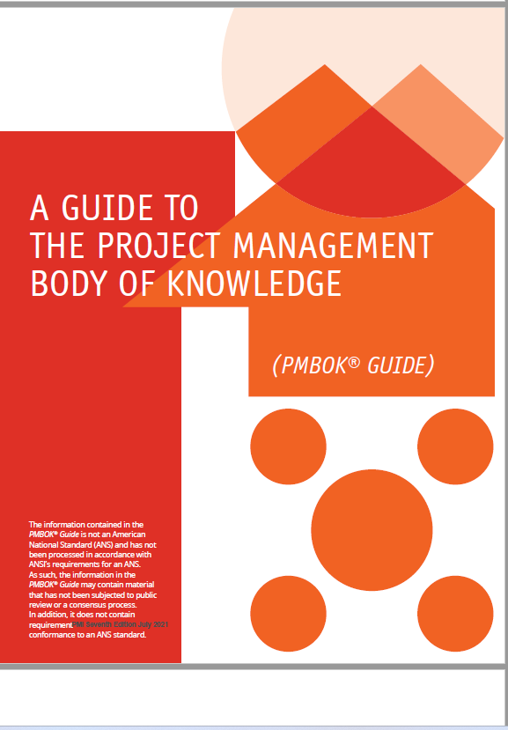

# A Guide to the Project Management Body of Knowledge

**Structure of the PMBOK® GUIDE**

*A Guide to the Project Management Body of Knowledge (PMBOK*® *Guide)* – Seventh Edition. It describes the relationship of the *PMBOK*® *Guide* to *The Standard for Project Management* [1],1 change’s to the *PMBOK*® *Guide*, the relationship to PMIstandards+™ (PMI’s digital platform for standards), and provides a brief overview of the content

In addition to this Introduction, this edition of the *PMBOK*® *Guide* contains three sections:-

Section 1 Project Performance Domains: This section identifies and describes eight project performance domains that form an integrated system to enable successful delivery of the project and intended outcomes.

Section 2 Tailoring: This section describes what tailoring is and presents an overview of what to tailor and how to go about tailoring individual projects.

Section 3 Models, Methods, and Artifacts: This section presents a brief description of commonly used models, methods, and artifacts. These models, methods, and artifacts illustrate the range of options project teams can use to produce deliverables, organize work, and enable communication and collaboration.

## Section 1. Project Performance Domains

**Principles and Performance Domain**

* Domains are a group of related activities that are critical for the effective delivery of project outcomes.
* They are interactive, interrelated, and interdependent areas of focus that work in unison to achieve desired project outcomes.
* They operate as an integrated system, with each domain being interdependent of the other domains to enable successful delivery of the project and its intended outcomes.
* The specific activities undertaken within each of the performance domains are determined by the context of the organization, the project, deliverables, the project team, stakeholders, and other factors.



### 1.1 Stakeholders Performance Domain

* Addresses activities and functions associated with stakeholders.
* A productive working relationship with stakeholders throughout the project.
* Stakeholder agreement with project objectives.
* Stakeholders who are project beneficiaries are supportive and satisfied while stakeholders who may oppose the project or its deliverables do not negatively impact project outcomes.
* Defining and sharing a clear vision at the start of the project can enable good relationships and alignment throughout the project

**Effective Stakeholder Engagement**

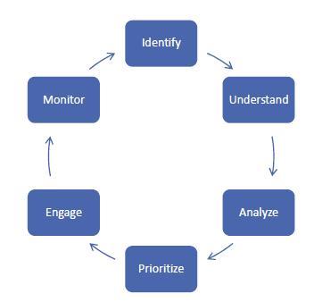

**Identify**

◦ Identification is done throughout the project to understand who your stakeholders are, both internal and external.

**Understand and Analyze**

◦ the project manager and the project team should seek to understand stakeholders’ feelings, emotions, beliefs, and values.

**Prioritize**

◦ Focus on stakeholders with the most power and interest as one way to prioritize engagement.

**Engage**

◦ Entails working collaboratively with stakeholders to introduce the project, elicit their requirements, manage expectations, resolve issues, negotiate, prioritize, problem solve, and make decisions.

**Monitor**

◦ Throughout the project, stakeholders will change as new stakeholders are identified and others cease to be stakeholders.

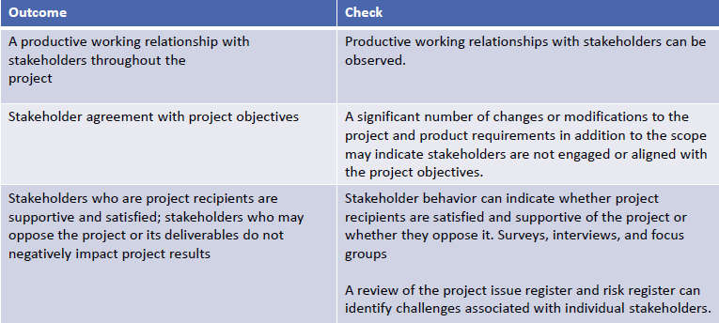

### 1.2 Team Performance Domain

Deals with activities and functions associated with the people who are responsible for creating project deliverables that realize business outcomes.

Outcomes includes:-

* Shared ownership
* A high-performing team
* Appropriate leadership and other interpersonal skills

This performance domain entails establishing the culture and environment that enables a collection of diverse individuals to evolve into a high-performing project team.

Terms used in this domain made of:

* Project Manager: Assign by the business to lead the team and is responsible for accomplishing the project objectives
* Project Management team: People who are directly involved in project management activities
* Project Team: A group of individuals performing the work of the project to achieve its purposes

Management activities includes:-

* Meeting project objectives,
* Effective processes, planning, coordinating, measuring, and monitoring work, among others.

Leadership activities includes:

* Influencing
* Motivating
* Listening
* Enabling

Leadership can be centralized and distributed.

* Centralized: Accountability (being answerable for an outcome), is usually assigned to one individual,
* Distributed: Shared among a project management team, and project team members

Servant leadership is a method of leadership that is based on the understanding and addressing the needs and development of project team members.

Servant leaders place emphasis on developing project team by focusing on addressing questions, such as:-

* Are project team members growing as individuals?
* Are project team members becoming healthier, wiser, freer, and more autonomous?
* Are project team members more likely to become servant leaders?

Servant leadership behaviors include:-

* Obstacle removal
* Diversion shield
* Encouragement and development opportunities

**Common Aspects of Team Development includes:-**

* Vision and objectives: Everyone are aware of the project vision and objectives
* Roles and responsibilities: members understand and fulfil their roles and responsibilities
* Project team operations: Facilitating project team communication, problem solving, and the process of coming to consensus
* Guidance: ensure everyone is headed in the right direction
* Growth: Identifying where the project team is carrying out well and pointing out areas where the project team can improve

**Project team culture:-**

* Each project team develops its own team culture.
* The project manager is important in establishing and maintaining a safe, respectful, non-judgmental environment that allows the project team to communicate openly.
* This is accomplished this is by modelling behaviors such as:-
* Transparency
* Integrity
* Respect
* Positive discourse
* Support
* Courage
* Celebrating success

**High Performing Project Teams**

Here are a Number of factors that contribute to high-performing project teams:-

* Open communication
* Shared understanding
* Shared ownership
* Trust
* Collaboration
* Adaptability
* Resilience
* Empowerment
* Recognition

**Leadership**

Leadership skills are valuable for all project team members whether the project team is operating. This includes:-

* Establishing and Maintaining Vision
* Critical Thinking
* Motivation
* Interpersonal Skills
* Emotional intelligence. Being able to be self-aware, self-manage and have social awareness and social skills.
* Decision making.
* Conflict management

Leadership methods are also tailored to meet the needs of the project, the environment, and the stakeholders. This can depend on:

* Experience with the type of project
* Maturity of the project team members
* Organizational governance structures
* Distributed project teams

**Possible outcomes with results**

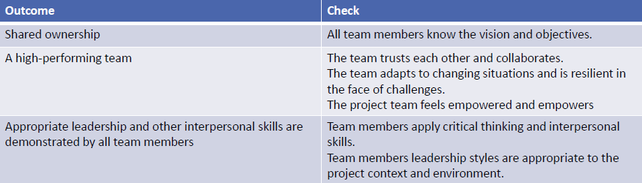

### 1.3 Development Approach and Life Cycle Performance Domain

* Deals with activities and functions associated with the development approach, cadence, and life cycle phases of the project.
* Delivery cadence refers to the timing and frequency of project deliverables.
* Outcomes includes:-
* Correct development approaches.
* A project life cycle that connects the delivery of business and stakeholder value from the beginning to the end of the project.
* A project life cycle consisting of phases that facilitate the delivery cadence and development approach required to produce the project deliverables.
* Projects can have a single delivery, multiple deliveries, or periodic deliveries.
* A development approach is the means used to create and evolve the product, service, or result during the project life cycle.
* There are different development approaches. Three common approaches include:-
* Predictive approach
* Adaptive approach, including both iterative and incremental
* Hybrid approach
* There are several factors that influence the selection of a development approach:-
* Product, service, or result
* Degree of innovation
* Requirements certainty
* Scope stability
* Ease of change
* Delivery options
* Risk
* Safety requirements
* Regulations
* The project
* Stakeholders
* Schedule constraints
* Funding availability
* Organization
* Organizational structure
* Culture
* Organizational capability
* Project team size and location
* The type and number of project phases in a project life cycle rest on upon many things..

One example of a life cycle can be:

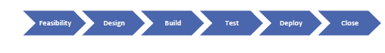

**Possible outcomes with results**

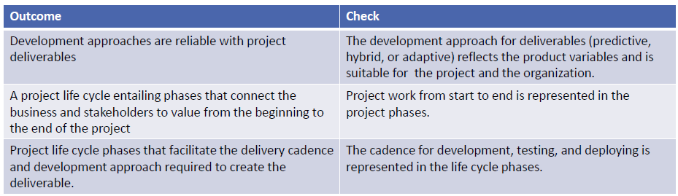

### 1.4 Planning Performance Domain

* Deals with activities and functions associated with the initial, ongoing, and evolving organization and coordination necessary for delivering project deliverables and outcomes.
* The purpose of planning is to proactively develop an approach to create the project deliverables.
* Outcomes includes:
* The project moves in an organized, coordinated, and deliberate manner.
* There is a holistic approach to providing the project outcomes.
* Evolving information is elaborated.
* Time spent planning is appropriate.
* Planning is sufficient to manage stakeholder expectations.
* There is a process for the adaptation of plans.
* Because each project is unique, the volume, timing, and frequency of planning varies.
* Variables include, but are not limited to:
* Development approach
* Project deliverables
* Organizational requirements
* Market conditions
* Legal or regulatory restrictions
* When planning things to consider will be:-
* Delivery – What is the scope being delivered by the project
* Estimating – Scope, schedule, budget of resources both people and physical
* Schedules - Models used to determine when work has to be done
* Budget- How much work will cost
* Planning for how the team will be made begins with identifying the skill sets required to accomplish the project work.
* Communication planning overlaps with stakeholder identification, analysis, prioritization, and engagement
* Physical resources apply to any resource that is not a person.
* Procurements can happen at any time during a project.
* There will be changes throughout the project.
* Some changes are a result of a risk event and others are due to customer requests or other reasons

**Possible outcomes with results**

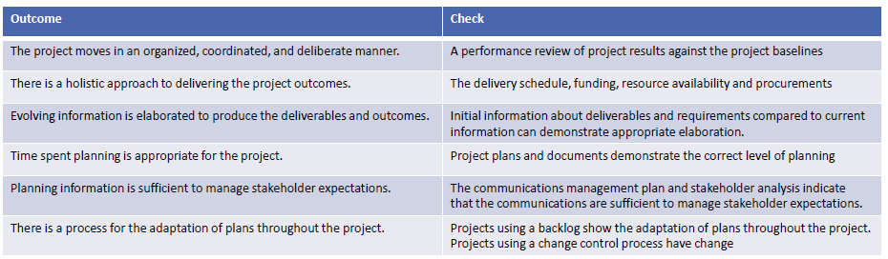

### 1.5 Project Work Performance Domain

* Deals with activities and functions associated with establishing project processes, managing physical resources, and fostering a learning environment.
* Project work is connected with establishing the processes and performing the work done by the project team to deliver the expected deliverables and outcomes.
* Outcomes includes:-
* Efficient and effective project performance.
* Project processes are suitable for the project and the environment.
* Appropriate communication with stakeholders.
* Efficient management of physical resources.
* Effective management of procurements.
* Improved team capability due to continuous learning and process improvement.
* Project work keeps the project team dedicated and project activities running correctly. This includes but is not limited to:-
* Managing the flow of existing, new and change work.
* Keeping the project team focused
* Establishing an efficient project systems and processes
* Communicating with stakeholders
* Managing physical resources
* Working external vendors
* Monitoring changes
* Enabling project learning and knowledge transfer.
* The project manager and the project team establish and periodically review the processes the project team is using to conduct the work.
* This can take the form of reviewing task boards such as using Kanban.
* Process tailoring can be used to optimize the process for the needs of the project
* Balancing constraints can take the form of fixed delivery dates, compliance to regulatory codes, a predetermined budget, and quality.
* Project managers have a responsibility for assessing and balancing the project team focus and attention.
* Much of the project work is associated with communication and engagement.
* Some projects require materials and supplies from third parties.
* Planning, ordering, transporting, storing, tracking, and controlling these physical resources can take a large amount of time and effort.
* Working on procurements which can involve hiring and managing vendors throughout the project. This includes managing bids and contracts.
* Monitoring new work and changes.
* From time to time, the project team may meet to determine what they can do better in the future (lessons learned) and how they can improve and challenge the process in upcoming iterations
* (retrospectives).

**Possible outcomes with results**

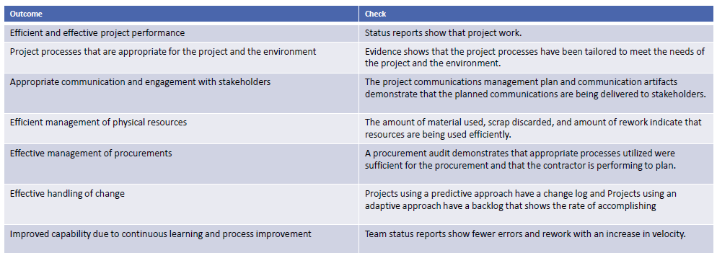

### 1.6 Project Delivery Performance Domain

* Deals with activities and functions associated with delivering the scope and quality that the project was undertaken to achieve.
* Outcomes includes:-
* Projects contribute to business objectives
* Projects realize the outcomes
* Project benefits are realized in the time frame
* The project team has an understanding of requirements.
* Stakeholders accept and are satisfied with project deliverables.
* Project delivery is about meeting requirements, scope, and quality expectations to produce the expected deliverable.
* Some project deliver value throughout and others deliver the bulk at the end.
* The project manager will need to understand how the deliverable is able to deliver value to the stakeholders. This includes:
* Requirements gathering.
* Evolving and discovering requirements
* Managing requirements
* Define and decompose the scope
* Completion of deliverables
* Quality requirements can be reflected in the completion criteria, definition of done, statement of work, or requirements documentation.
* The project manager must the following of quality:
* Cost of Quality
* Prevention.
* Appraisal.
* Internal Failure
* External Failure
* Cost of Change

**Possible outcomes with results**

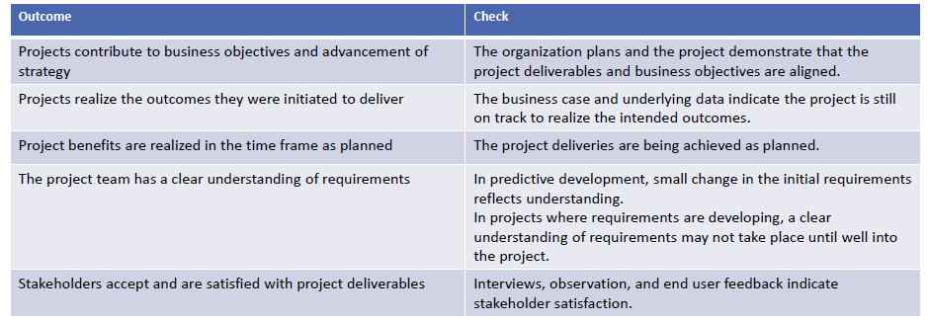

### 1.7 Measurement Performance Domain

* Deals with activities and functions associated with assessing project performance and taking appropriate actions to maintain acceptable performance.
* Outcomes includes:
* A reliable understanding of the status of the project.
* Actionable data to enable decision making.
* Timely and appropriate actions to keep the project on track.
* Achieving targets and generating business value
* Involves measuring project performance and implementing appropriate responses to keep the project on track.
* This domain evaluates the amount to which the work done in the Delivery Performance Domain is meeting the metrics identified in the Planning Performance Domain.
* Measures are used for multiple reasons, including:-
* Evaluating performance compared to plan
* Tracking the utilization of resources
* Demonstrating accountability
* Providing information to stakeholders
* Assessing whether project deliverables are on track
* Ensuring the project deliverables will meet customer acceptance criteria.
* Creating effective measurements helps to ensure the right things are measured.
* Ways to measure performance include:-
* Key Performance Indicators (KPI) - two types of KPIs: leading indicators and lagging indicators.
  + Leading indicators predict changes or trends in the project
  + Lagging indicators measure project deliverables or events. They provide information after the fact.
* Effective Metrics
  + Use of SMART (Specific, Meaningful, Achievable, Relevant, Timely) criteria.
* What to measure includes:-
* Deliverable Metrics
* Information on errors or defects
* Measures of performance
* Delivery
* Work in progress
* Lead time
* Cycle time
* Process efficiency
* Baseline Performance
* Start and finish dates
* Actual cost compared to planned cost
* Resources
* Planned resource utilization compared to actual resource utilization
* Business Value
* Cost-benefit ratio
* Stakeholders
* Mood chart
* Forecasts
* Metrics can be presented using:
* Dashboards
* Information Radiators
* Visual Controls
* Pitfalls associated with measurement includes:
* Hawthorne effect
* Vanity metric
* Demoralization
* Misusing the metrics
* Confirmation bias
* A portion of measurement is having agreed to plans for measures that are outside the threshold ranges.
* Thresholds can be established for a assortment of metrics such as schedule, budget, velocity, and other project-specific measures.

**Possible outcomes with results**

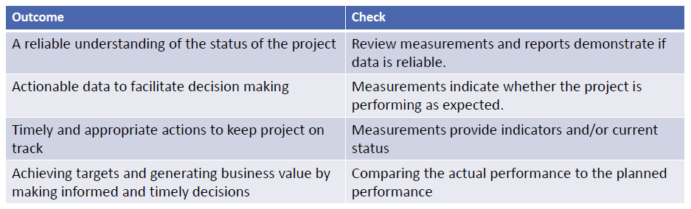

### 1.8 Uncertainty Performance Domain

* Deals with activities and functions associated with risk and uncertainty.
* Effective execution of this performance domain results in the following desired outcomes:
* An awareness of the environment in which projects occur
* Proactively exploring and responding to uncertainty.
* An awareness of the interdependence of multiple variables on the project.
* The capacity to anticipate threats and opportunities
* Project delivery with little or no negative impact
* Opportunities are realized to improve project performance and outcomes.
* Cost and schedule reserves are utilized
* Projects happen in environments with varying degrees of uncertainty.
* Uncertainty in the broadest sense is a state of not knowing or unpredictability.
* Uncertainty presents threats and opportunities that project teams explore, assess, and decide how to handle.
* There are many shades to uncertainty, such as:-
* Risk associated with not knowing future events
* Ambiguity associated with not being aware of current or future conditions
* Complexity associated with dynamic systems having unpredictable outcomes.
* Options for responding to uncertainty: -
* Gather information
* Prepare for multiple outcomes
* Build in resilience
* Volatility exists in an environment that is subject to rapid and unpredictable change.
* Volatility can occur when there are ongoing fluctuations in available skill sets or materials.
* Risks are an aspect of uncertainty.

**Possible outcomes with results**

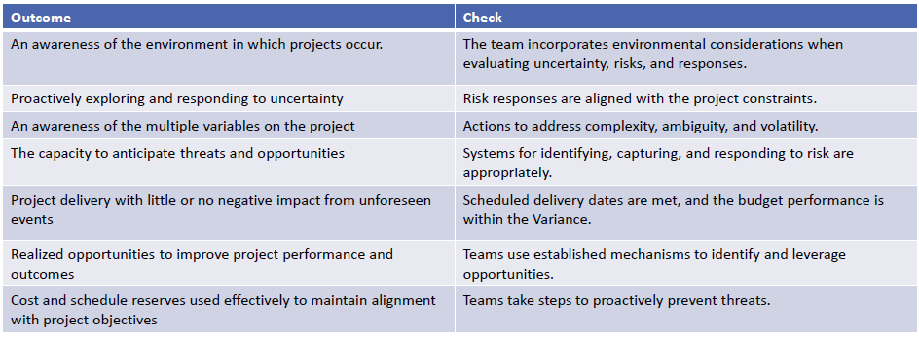

## Section 2. Tailoring

**2.1 Overview**

* Tailoring is the deliberate adaptation of the project management approach, governance, and processes to make them more suitable for the given environment and the work at hand.
* Tailoring involves understanding the project context, goals, and operating environment. Projects operate in complex environments that need to balance potentially competing demands that include, but are not limited to: -
* Delivering as quickly as possible
* Minimizing project costs
* Optimizing the value delivered
* Creating high-quality deliverables and outcomes
* Providing compliance with regulatory standards
* Satisfying diverse stakeholder expectations
* Adapting to change

**Benefits of Tailoring**

Tailoring produces direct and indirect benefits to organizations. These include, but are not limited to: -

* More commitment from project team members who helped to tailor the approach,
* Customer-oriented focus, as the needs of the customer are an important influencing factor in its development
* More efficient use of project resources.

**Tailoring Concept**

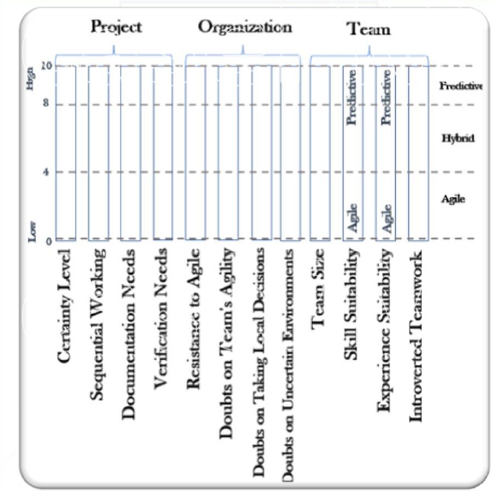

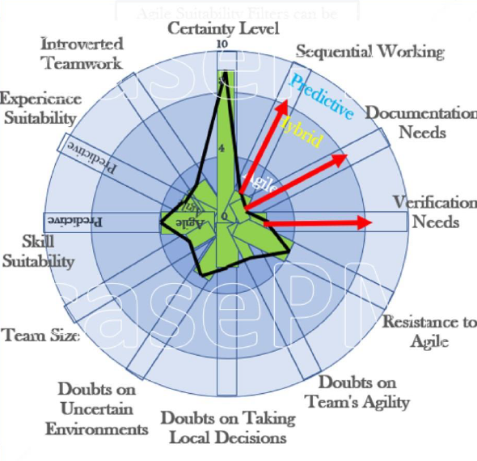

**2.2 What to tailor?**

Project aspects that can be tailored include: -

* Life cycle and development approach selection
* Processes
* Engagement
* Tools
* Methods and artifacts

Life cycle and development approach selection

Deciding on a life cycle and the phases of the life cycle is an example of tailoring. Additional tailoring can be done when selecting the development and delivery approach for the project. Some large projects may use a combination of development and delivery approaches simultaneously.

For instance, building a new data center could involve (a) the use of predictive approaches for the physical building construction and finishing and (b) an iterative approach for understanding and establishing the computing capabilities required. Viewed from a project level, this combination of approaches represents a hybrid approach, but the construction team and the computing team may only experience a predictive or iterative development approach.

Processes

Process tailoring for the selected life cycle and development approach includes determining

which portions or elements should be: -

* Added, to bring required rigor, coverage, or address unique product or operating environment conditions, etc. (e.g., adding independent inspections for safety-critical projects);
* Modified, to better suit the project or project team requirements (e.g., modifying the format of project documents to accommodate project team members with vision limitations);
* Removed, to reduce cost or effort since it is no longer required or is not economical for the value it adds (e.g., removing the creation of meeting minutes for a small, collocated project team with good communications);
* Blended, to bring additional benefits or value by mixing or combining elements (e.g., adding appreciative inquiry methods from organizational management to the lessons learned meetings of predictive project management to help foster better collaboration)
* Aligned, to harmonize elements so there is consistent definition, understanding, and application (e.g., many disciplines have standards and practices associated with risk management that are sufficiently different from each other that would need to be aligned). For example, on multidisciplinary project teams, different disciplines may have specific elements, such as their own language, tools, and practices related to the same area of focus.

Engagement

Tailoring engagement for the people involved in the project includes:-

* People: This entails evaluating the skills and capabilities of the project leadership and the project team; then selecting who should be involved and in what capacities based on the project type and operating conditions. For example, on a challenging or time-constrained project, assigning very experienced project team members is more logical than using inexperienced project team members.
* Empowerment: Empowerment involves choosing which responsibilities and forms of local decision making should be deferred to the project team. Some environments and team member capabilities support high levels of empowerment. In other situations, less empowerment with more supervision and direction might be preferable.
* Integration: Project teams can include contributors from contracted entities, channel partners, and other external entities in addition to staff from inside the sponsoring organization. Tailoring considers how to create one project team from a diverse collection of contributors to facilitate optimal project team performance and realization of project outcomes.

**Tools**

Selecting the tools (e.g., software or equipment) the project team will use for the project is a form of tailoring. Often, the project team has the best insight into the most suitable tools for the situation, but those choices might need tempering based on the associated costs. Additionally, organizational leaders can impose constraints that the project team cannot change.

**Methods and artifacts**

Tailoring the means that will be used to achieve the project outcomes is performed so that the methods are suited for the environment and the culture. Tailoring the documents, templates, and other artifacts that will be used on the project helps to make sure the artifacts are appropriate for the project and the organization.

**2.3 Tailoring Process**

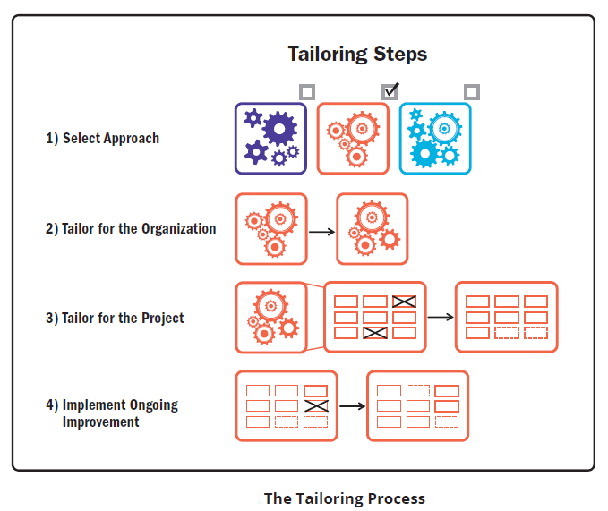

**Tailor the Project**

Many attributes influence tailoring for the project. These include, but are not limited to:

* Product/deliverable
* Project team
* Culture

The project team should ask questions about each attribute to help guide them in the tailoring process. Answers to these questions can help identify the need to tailor processes, delivery approach, life cycle, tools, methods, and artifacts.

**Product/Deliverable**

Attributes associated with the product or deliverable include, but are not limited to:-

* **Compliance/criticality**:- How much process rigor and quality assurance is appropriate?
* **Type of product/deliverable**:- Is the product well known and physical, for example, something easy to recognize and describe like a building? Or something intangible like software or the design of a new drug?
* **Industry market**:- What market does the project, product, or deliverable serve? Is that market highly regulated, fast moving, or slow to evolve? What about competitors and incumbents?
* **Technology**:- Is the technology stable and well established or rapidly evolving and at risk of obsolescence?
* **Time frame**:- Is the project time frame short as in weeks or months, or long as in several years?
* **Stability of requirements**:- How likely are there to be changes to core requirements?
* **Security**:- Are elements of the product business confidential or classified?
* **Incremental delivery**:- Is this something the project team can develop and get stakeholder feedback on incrementally, or something that is hard to evaluate until near completion?

**Project Team**

Project team considerations include:-

* **Project team size**:- How many full-time and part-time people will be working on the project?
* **Project team geography**:- Where are the team members predominantly located geographically? Will some or all of the team be remote or colocated?
* **Organizational distribution**:- Where are the team’s supporting groups and other stakeholders located?
* **Project team experience**:-Do the project team members have any experience in the industry, in the organization, or working with each other? Do they have the skills, tools, and technology required for the project under consideration?
* **Access to customer**:- Is it practical to get frequent and timely feedback from customers or customer representatives?

**Culture**

Evaluating the culture includes considerations regarding:-

* **Buy-in**:- Is there acceptance, support, and enthusiasm for the proposed delivery approach?
* **Trust**:- Are there high levels of trust that the project team is capable of and committed to delivering the project outcomes?
* **Empowerment**:- Is the project team trusted, supported, and encouraged to own and develop its working environment, agreements, and decisions?
* **Organizational culture**:- Do the organizational values and culture align with the project approach? This includes empowering versus specifying and checking, trusting local decision making versus requesting external decision making, etc.

**2.4 Tailoring Performance Domains**

The Performance Domains can also be tailored too,

* Stakeholders
* Team
* Development Approach & Life Cycle
* Planning
* Project Work
* Delivery
* Measurement
* Uncertainty

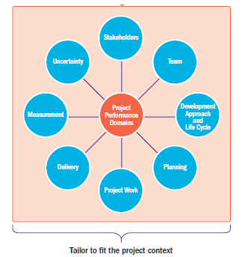

**Stakeholders**

When tailoring the Stakeholders Performance Domain consider: -

* The overall work environment
* Cultural diversity
* The number of Stakeholders

**Team**

When tailoring the Team Performance Domain consider: -

* The overall work environment
* Cultural diversity
* The number of team members
* Skills and experience levels of team members
* Organizational human resource development strategy

**Development Approach & Life Cycle**

When tailoring the Development Approach & Life Cycle consider: -

* Certainty level
* Sequential working
* Documentation and verification need
* Resistance to Agile
* Doubts on team's Agility, taking local decisions, and uncertain environments
* Team size, skills and experience
* Introverted teamwork

**Planning**

When tailoring the Planning consider: -

* All the factors that may affect any component of the project
* Organizational procedures, templates and process
* The number of sellers
* The business environment

**Project Work**

When tailoring the Project Work consider: -

* The Management Process
* How to manage and transfer the knowledge and information such as:-
* The software to be used
* Ongoing Projects
* Similar Projects completed before
* Organizational procedures and processes

**Delivery**

When tailoring the Delivery consider: -

* The organizational procedures and processes about how to identify and manage the project requirements and quality of deliverables
* The Business Environment
* If the requirements are clear or not

**Measurement**

When tailoring the Measurement consider: -

* The measurement activities related to benefits realization
* How we measure the business value
* Customer requirements on monitoring and controlling
* Organizational requirements on monitoring and controlling

**Uncertainty**

When tailoring the Measurement consider: -

* The Risk Appetite and Risk Tolerance
* The Development Approach & the Life Cycle
* The Project Size
* The level of Uncertainty
* The organizational process and procedures about Risk Management
* Importance level of the Project

## Section 3. Tailoring Models, Methods & Artifacts

**3.1 Introduction**

**Model.** A model is a thinking strategy to explain a process, framework, or phenomenon

**Method.** A method is the means for achieving an outcome, output, result, or project deliverable

**Artifact.** An artifact can be a template, document, output, or project deliverable

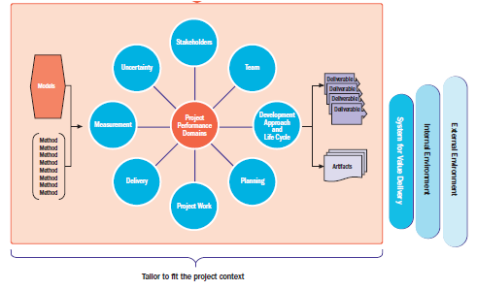

|  |  |  |
| --- | --- | --- |
| **Strategies**  **Approaches**  **Theories**  **Scenarios** |  | |
| **Models** | **Techniques (Methods)** | **Artifact** |
| * Leadership * Motivation * Project Team Development * Communications * Changes * Complexity * Etc., | * Data Gathering and Analysis * Estimating * Meetings * Etc., | * Strategy * Documents * Contracts * Plans * Baselines * Registers and Logs * Hierarchy Charts * Diagrams & Charts * Reports * Etc., |

**3.2 Models**

**3.2.1 Leadership Models**

**Situational Leadership Model**

Situational leadership models are a subset of a vast array of leadership models. Just as project teams tailor the processes, methods, life cycles, and development approaches, leadership styles are also tailored. Situational leadership models describe ways to tailor one’s leadership style to meet the needs of the individual and the project team. The following are examples of two situational leadership models.

**Situational Leadership® II**

Ken Blanchard’s Situational Leadership® II measures project team member development using competence and commitment as the two main variables. Competence is the combination of ability, knowledge, and skill. Commitment speaks to the confidence and motivation an individual has. As an individual’s competence and commitment evolve, leadership styles evolve from directing to coaching to supporting to delegating in order to meet the individual’s needs.

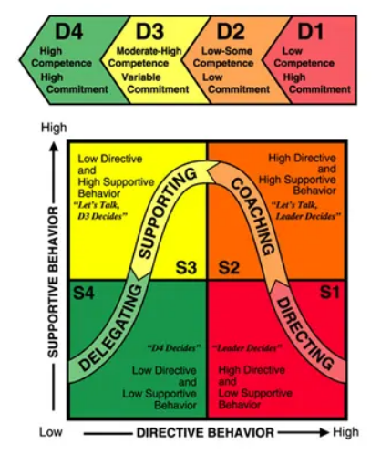

**OSCAR Model**

The OSCAR coaching and mentoring model was developed by Karen Whittleworth and Andrew Gilbert. It helps individuals adapt their coaching or leadership styles to support individuals who have an action plan for personal development.

The model refers to five contributing factors:-

* **Outcome**:- An outcome identifies the long-term goals of an individual and the desired result from each conversation session.
* **Situation**:- A situation enables conversation about the current skills, abilities, and knowledge level of the project team member; why the person is at that level; and how that level impacts the individual’s performance and peer relationships.
* **Choices/consequences**:- Choice and/or consequences identify all the potential avenues for attaining the desired outcome and the consequences of each choice so an individual can choose viable avenues for reaching their long-term goals.
* **Actions**:- An action commits to specific improvements by focusing on immediate and attainable targets that an individual can work toward within a specified time frame.
* **Review**:- Holding regular meetings offers support and helps to ensure that individuals remain motivated and on track.

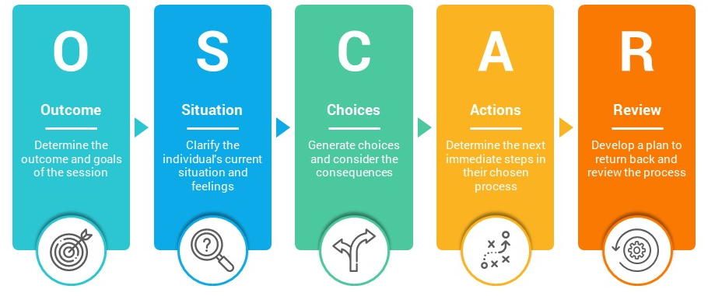

**3.2.2 Motivation Model**

People perform better when they are motivated, and people are motivated by different things. Understanding what motivates project team members and other stakeholders helps to tailor rewards to the individual, thereby eliciting more effective engagement. There are a significant number of models that illustrate how people are motivated. Four models are described in Sections.

**Hygiene and Motivational Factors**

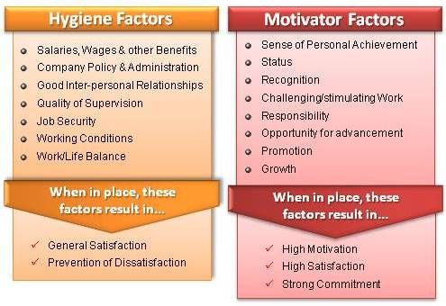

Frederick Herzberg conducted a study of motivational factors in working life. He believed that job satisfaction and dissatisfaction stem from conditions called motivational factors. Motivational factors include matters that relate to the content of the work, such as achievement, growth, and advancement. Insufficient motivational factors lead to dissatisfaction. Sufficient motivational factors lead to satisfaction.

Herzberg also identified hygiene factors related to the work, such as company policies, salary, and the physical environment. If hygiene factors are insufficient, they cause dissatisfaction. However, even if they are sufficient, they do not lead to satisfaction.

**Intrinsic versus Extrinsic Motivation**

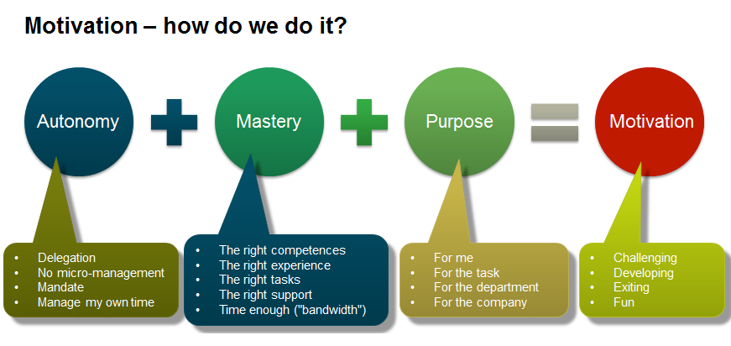

Daniel Pink published several books about the intrinsic factors that motivate people. He stated that while extrinsic rewards, such as salary, are motivators to a certain extent, once a person is paid fairly for their work, the motivational power of extrinsic rewards ceases to exist. For complicated and challenging work, such as much of the work on projects, intrinsic motivators are far longer lasting and more effective. Pink identifies three types of intrinsic motivators: autonomy, mastery, and purpose: -

* **Autonomy**: Autonomy is the desire to direct one’s own life. This is aligned with being able to determine how, where, and when to accomplish work. Autonomy includes flexible work hours, working from home, and work on self-selecting and self-managing project teams.
* **Mastery:** Mastery is about being able to improve and excel. The desire to do excellent work, learn, and achieve goals are aspects of mastery.
* **Purpose:** Purpose speaks to the need to make a difference. Knowing the project vision and how work contributes to achieving that vision allows people to feel like they are making a difference.

**Theory of Needs**

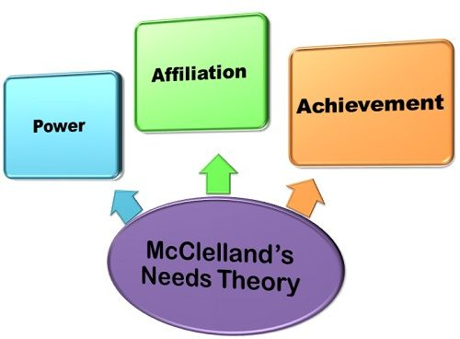

David McClellan’s model states that all people are driven by needs of achievement, power, and affiliation. The relative strength of each need depends on an individual’s experiences and culture.

* Achievement. People who are motivated by achievement, such as reaching a goal, are motivated by activities and work that is challenging, but reasonable.
* Power. People who are motivated by power like to organize, motivate, and lead others. They are motivated by increased responsibility.
* Affiliation. People who are motivated by affiliation seek acceptance and belonging. They are motivated by being part of a team.

**Theory X, Theory Y, and Theory Z**

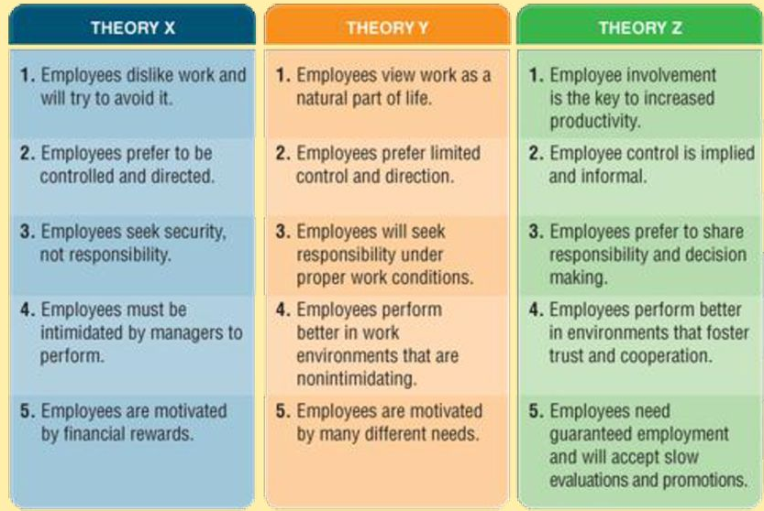

Douglas McGregor devised the Theory X and Theory Y models, which represent a spectrum of employee motivation and corresponding management styles. This was later expanded to

include Theory Z.

* Theory X. The X side of the spectrum assumes individuals work for the sole purpose of income. They are not ambitious or goal oriented. The corresponding management style to motivate these individuals is a hands-on and top-down approach. This management style is often seen in a production or labor-intensive environment, or one with many layers of management.
* Theory Y. The Y side of the spectrum assumes that individuals are intrinsically motivated to do good work. The corresponding management style has a more personal coaching feel. The manager encourages creativity and discussion. This management style is often seen in creative and knowledge worker environments.
* Theory Z. Abraham Maslow saw Theory Z as a transcendent dimension to work where individuals are motivated by self-realization, values, and a higher calling. The optimal management style in this situation is one that cultivates insight and meaning. William Ouchi’s version of Theory Z focuses on motivating employees by creating a job for life where the focus is on the well-being of employees and their families. This style of management seeks to promote high productivity, morale, and satisfaction.

**3.2.3 Project Team Development Model**

Project teams move through different stages of development. Understanding the stage of the team in its development helps project managers support the project team and its growth. The two models presented in Sections to illustrate how project teams move through different stages to become high-performing project teams.

**Tuckman Ladder**

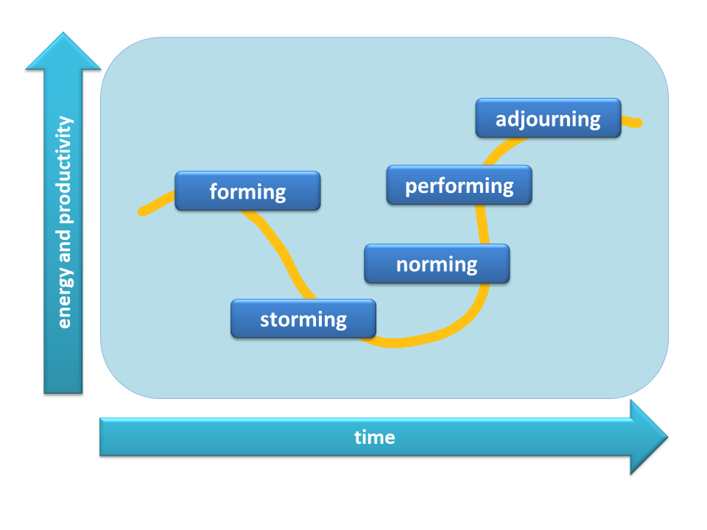

Bruce Tuckman articulated the stages of team development as forming, storming, norming, and performing. Many people add a fifth stage, adjourning.

* **Forming**: -The project team first comes together. Members get to know each other’s name, position on the project team, skill sets, and other pertinent background information. This might occur in the kickoff meeting.
* **Storming**: -Project team members jockey for position on the team. This phase is where people’s personalities, strengths, and weaknesses start to come out. There might be some conflict or struggle as people figure out how to work together. Storming might go on for some time or pass relatively quickly.
* **Norming**: -The project team starts to function as a collective body. At this point, project team members know their places on the team and how they relate to and interface with all the other members. They are starting to work together. There might be some challenges as work progresses, but these issues are resolved quickly, and the project team moves into action.
* **Performing**: - The project team becomes operationally efficient. This is the mature project team stage. Project teams that have been together for a while are able to develop a synergy. By working together, project team members accomplish more and produce a high-quality product.
* **Adjourning**: - The project team completes the work and disperses to work on other things. If the project team has formed good relationships, some project team members might be sad about leaving the project team.
* The project team culture in this model starts in the forming stage and evolves throughout the rest of the development stages. While this model shows a linear progression, project teams can move back and forth between theses stages. In addition, not all project teams achieve the performing or even the norming stages.

**Drexler/Sibbet Team Performance Model**

Allan Drexler and David Sibbet developed a team performance model with seven steps. Steps 1 through 4 describe the stages in creating a project team, and steps 5 through 7 cover project team sustainability and performance.

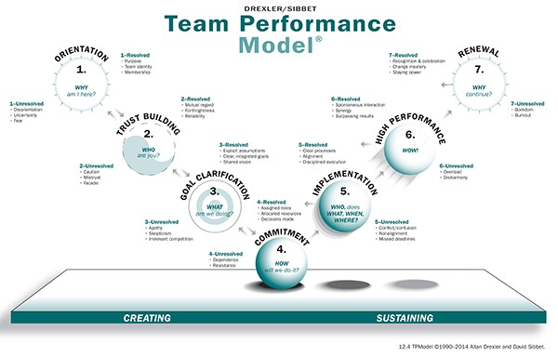

* **Step 1**: - Orientation. Orientation answers the question of why. In this stage, the project team learns the purpose and mission for the project. This usually occurs at a kickoff meeting, or is documented in a business case, project charter, or lean start-up canvas.
* **Step 2**: - Trust building. Trust building answers the question of who. This stage sheds light on who is on the project team and the skills and abilities each person brings. It can also include information about key stakeholders who may not be part of the project team but can influence the project team.
* **Step 3**: - Goal clarification. Goal clarification answers what. In this stage, the project team elaborates the high-level project information. This may include finding out more about stakeholder expectations, requirements, assumptions, and deliverable acceptance criteria.
* **Step 4**: - Commitment. Commitment addresses the question of how. In this stage, the project team starts to define plans to achieve the goals. This can include milestone schedules, release plans, high-level budgets, resource needs, and so forth.
* **Step 5**: - Implementation. High-level plans are decomposed into greater levels of detail, such as a detailed schedule or backlog. The project team starts working together to produce deliverables.
* **Step 6**: - High performance. After the project team has worked together for some time, project team members reach a high level of performance. They work well together, don’t need much oversight, and experience synergies within the project team.
* **Step 7**: - Renewal. Renewal is the stage of working through changes on the project team or the project. The deliverables, stakeholders, environment, project team leadership, or team membership may change. This causes the project team to consider if the past behavior and actions are still sufficient, or if the project team needs to go back to a previous stage to reset the expectations and ways of working together.

**3.2.4 Communications Model**

Project success is dependent on effective communication. Communication models demonstrate concepts associated with how sender and receiver frames of reference impact the effectiveness of communication, how the communication medium influences the effectiveness of communication, and the types of disconnects between end-user expectations and reality. With the prevalence of multicultural project teams and dispersed stakeholders, these models provide a way of viewing communication styles and methods to enhance communication efficiency and effectiveness.

**Cross-Cultural Communication**

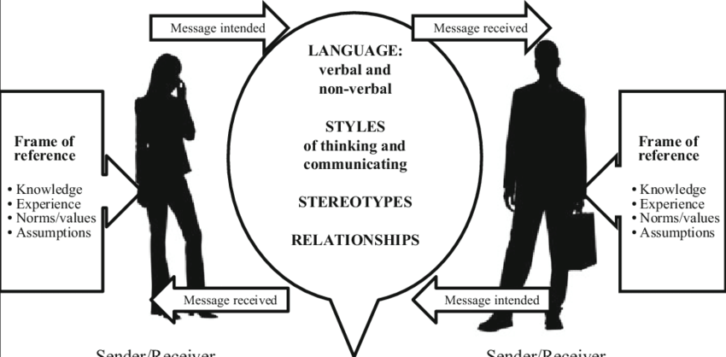

A communication model developed by Browaeys and Price incorporates the idea that the message itself and how it is transmitted is influenced by the sender’s current knowledge, experience, language, thinking, and communication styles, as well as stereotypes and relationship to the receiver. Similarly, the receiver’s knowledge, experience, language, thinking, and communication styles, as well as stereotypes and relationship to the sender will influence how the message is interpreted.

**Effectiveness of Communication Channels**

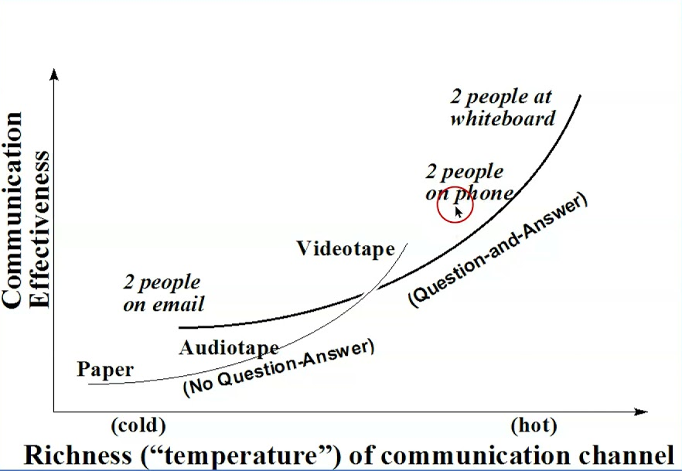

Alistair Cockburn developed a model that describes the communication channels along the axes of effectiveness and richness. As defined by Richard Daft and Robert Lengel, richness relates to the amount of learning that can be transmitted through a medium. Media richness is a function of characteristics, including the ability to:

* Handle multiple information cues simultaneously,
* Facilitate rapid feedback,
* Establish a personal focus, and
* Utilize natural language.

Richness in communication allows a broad spectrum of information to be conveyed rapidly. Situations that entail complex, complicated, and personal information benefit from richer communication channels, such as face-to-face communication. Situations that impart simple, factual information can use less rich communication channels such as a note or a text message.

**Gulf of Execution and Evaluation**

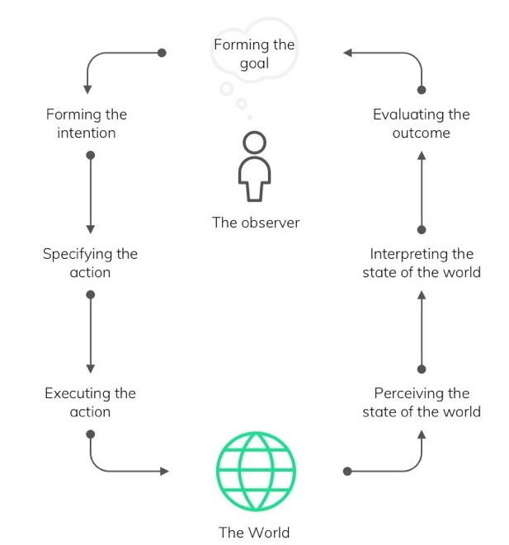

Donald Norman described the gulf of execution as the degree to which an item corresponds with what a person expects it to do. Said another way, it is the difference between the intention of a user and what the item allows them to do or supports them in doing. A car that has the ability to parallel park itself would have a gulf of execution if the driver expected to push a button labelled “park” and have the car park itself, and the car did not park itself.

The gulf of evaluation is the degree to which an item supports the user in discovering how to interpret the item and interact with it effectively. The same parking example would show a gulf of evaluation if the controls were not designed in such a way that the driver could easily determine how to initiate the self-parking function.

**3.2.5 Changes Model**

Many projects contain an aspect of changing systems, behaviors, activities, and sometimes, cultures. Managing this type of change requires thinking about how to transition from the current to the future desired state. There are many models that describe the activities necessary for successful change management. Below Sections provide a sampling of the change models.

**Managing Change in Organizations**

*A Practice Guide* [3] is an iterative model that is based on common elements across a range of change management models. The framework has five associated elements interconnected through a series of feedback loops:-

* **Formulate change**:- This element focuses on building the rationale to help people understand why change is needed and how the future state will be better.
* **Plan change**:- The identification of activities helps people prepare for the transition from the current to the future state.
* **Implement change**:- This iterative element focuses on demonstrating the future state capabilities, checking to ensure the capabilities are having the intended impact, and making necessary improvements or adaptations in response.
* **Manage transition**:- This element considers how to address needs related to the change that may surface once the future state is achieved.
* **Sustain change**. This element seeks to ensure that the new capabilities continue and previous processes or behaviors cease.

**ADKAR® Model**

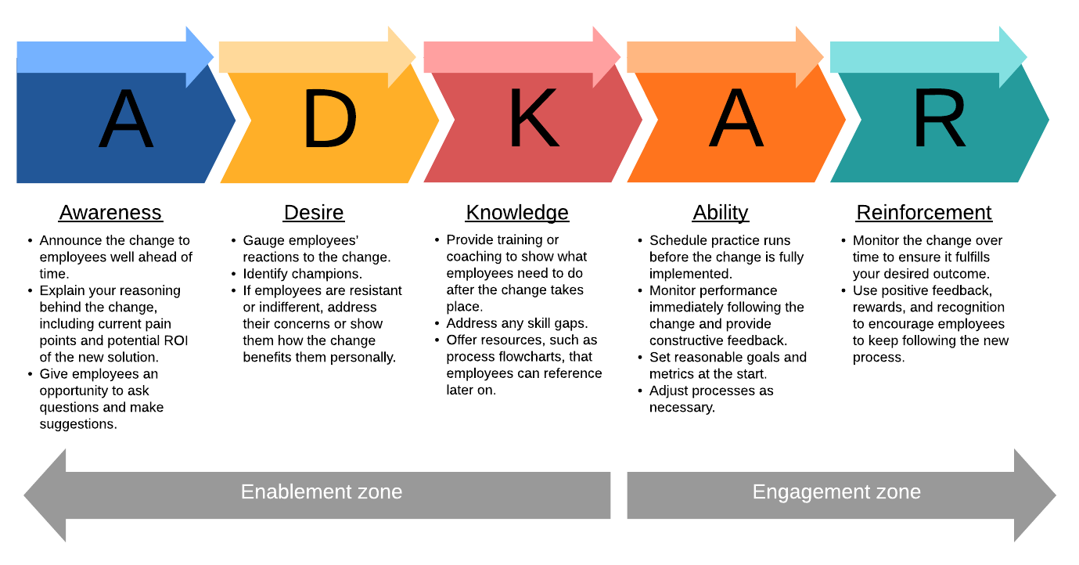

Jeff Hiatt developed the ADKAR® Model which focuses on five sequential steps that individuals

undergo when adapting to change:-

* **Step 1:** **Awareness**:- This step identifies why the change is necessary.
* **Step 2:** **Desire**:- Once people know why the change is necessary, there needs to be a desire to be part of and support the change.
* **Step 3:** **Knowledge**:- People need to understand how to change. This includes understanding new processes and systems in addition to new roles and responsibilities. Knowledge can be imparted through training and education.
* **Step 4:** **Ability**:- In this step, knowledge is supported with hands-on practice and access to expertise and help as needed.
* **Step 5:** **Reinforcement**:- Reinforcement supports the sustainment of the change. This can include rewards, recognition, feedback, and measurement.

**The 8-Step Process for Leading Change**

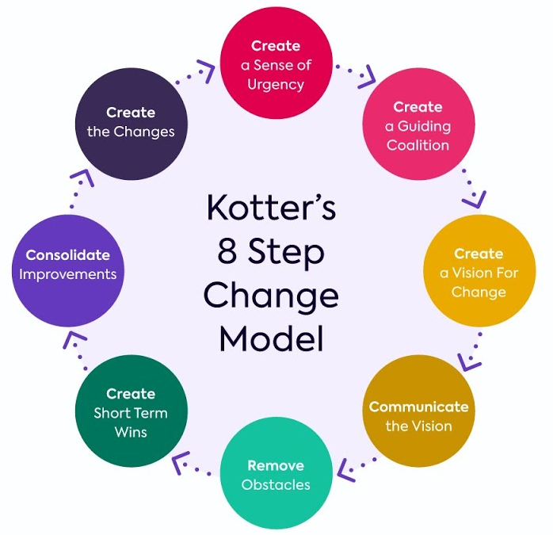

John Kotter introduced the 8-Step Process for Leading Change for transforming organizations. It is a top-down approach where the need for and approach to change originates at the top levels of the organization, and then is promoted down through the organization’s layers of management to the change recipients. The eight steps are:

* **Step 1:** Create urgency. Identify potential threats and opportunities that drive the need for change.
* **Step 2:** Form a powerful coalition. Identify the change leaders. Change leaders are not necessarily based on hierarchy. The change leaders should be influential people from a variety of roles, expertise, social, and political importance.
* **Step 3:** Create a vision for change. Identify the values that are central to the change. Then create a brief vision statement that summarizes the change. Next, identify a strategy to realize the vision.
* **Step 4:** Communicate the vision. Communicate the vision throughout the change process. Apply the vision throughout all aspects of the organization. Senior management and the change coalition should consistently communicate the vision and demonstrate the urgency and benefits of the change.
* **Step 5:** Remove obstacles. All change comes with obstacles. Sometimes the obstacles are outdated processes, sometimes they are based on the organizational structure, and sometimes they are people resistant to change. Regardless, all obstacles need to be addressed.
* **Step 6:** Create short-term wins. Identify quick and easy wins to build momentum and support for the change.
* **Step 7:** Build on the change. Once the short-term wins are complete, the organization needs to set goals for continued improvement.
* **Step 8:** Anchor the changes in corporate culture. Ensure the change becomes ingrained into the culture: continue to communicate the vision, tell success stories, recognize people in the organization who embody and empower the change, and continue to support the change coalition.

**Virginia Satir Change Model**

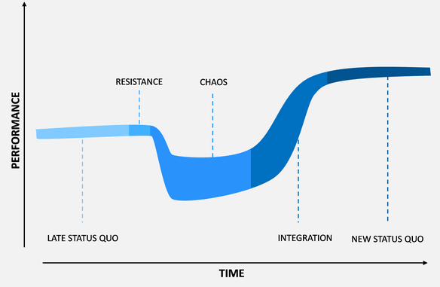

Virginia Satir developed a model of how people experience and cope with change. Its purpose is to help project team members understand what they are feeling and enable them to move through change more efficiently.

* Late status quo. This initial stage is when everything feels familiar and can be characterized as “business as usual.” For some people, business as usual may be good because they know what to expect. For others, this status may feel a bit stale or boring.
* The foreign element. Something happens that shifts the status quo in this stage. This may include initiating a project that introduces change to people’s usual way of working. There is often a period of resistance and reduction in performance after the change is introduced. People may ignore the change or dismiss its relevance.
* Chaos. People are in unfamiliar territory. They are no longer comfortable, and performance drops to its lowest level. Feelings, actions, and behaviors are unpredictable. Some people feel anxious, others may shut down, and some individuals may feel excited. Chaos can make people very creative as they try to find ways to make sense of the situation. They try various ideas and behaviors to see which of these has a positive outcome.
* The transforming idea. People come to a point where they come up with an idea that helps them make sense of the situation. They begin to see how they can find a way out of the chaos and cope with the new reality. Work performance begins to increase.
* Practice and integration. People try to implement their new ideas or behaviors. There may be setbacks and a period of trial and error, but eventually they learn what works and what doesn’t. This leads to improved performance. Often performance is at a higher level than it was before the foreign element was introduced.
* New status quo. People get used to the new environment, and their performance stabilizes. Eventually, the new status quo becomes the normal way of working.

**Transition Model**

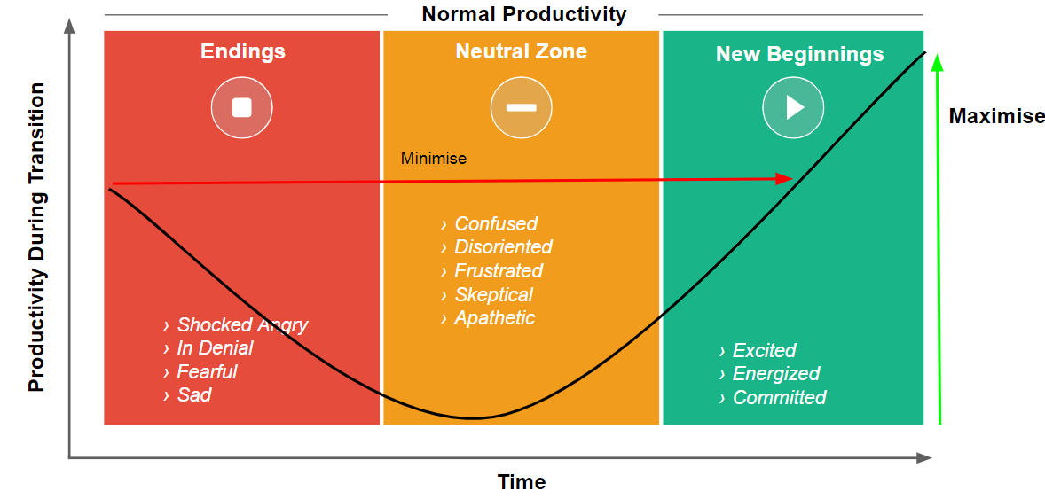

William Bridges’ Transition Model provides an understanding of what occurs to individuals psychologically when an organizational change takes place. This model differentiates between change

and transition. Change is situational and happens whether or not people transition through it. Transition is a psychological process where people gradually accept the details of the new situation and the changes that come with it.

The model identifies three stages of transition associated with change:-

* Ending, losing, and letting go. The change is introduced in this stage. It is often associated with fear, anger, upset, uncertainty, denial, and resistance to the change.
* The neutral zone. The change is happening in this stage. In some instances, people may feel frustration, resentment, confusion, and anxiety about the change. Productivity may drop as people learn new ways of doing work. In other instances, people may become very creative, innovative, and passionate about trying new ways of working.
* The new beginning. At this point, people accept and even embrace the change. They are becoming more adept at the new skills and the new ways of working. People are often open to learning and are energized by the change.

**3.2.6 Complexity Model**

Projects exist in a state of ambiguity and require interactions among multiple systems, often with uncertain outcomes. Complexity is a challenge to work with. The two models described in Below Sections provide a framework to understand complexity and determine how to make decisions in a complex environment.

**Cynefin Framework**

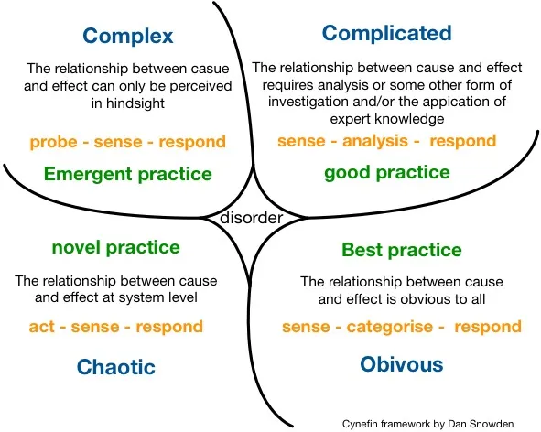

The Cynefin framework, created by Dave Snowden, is a conceptual framework used to diagnose cause-and-effect relationships as a decision-making aid. The framework offers five problem and decision-making contexts:-

Where there is an obvious cause-and-effect relationship, best practices are used to make decisions.

* Complicated relationships exist when there is a set of known unknowns or a range of correct answers. In these situations, it is best to assess the facts, analyze the situation, and apply good practices.
* Complex relationships include unknown unknowns. There is no apparent cause and effect, and there are no obvious right answers. In complex environments, one should probe the environment, sense the situation, and respond with action. This style uses emergent practices that allow for repeated cycles of probe-sense-respond as complex environments change in reaction to multiple stimuli, and what worked once may not be effective the next time.
* In chaotic environments, the cause and effects are unclear. There is too much confusion to wait to understand the situation. In these situations, the first step is to take action to try and stabilize the situation, then sense where there is some stability, and respond by taking steps to get the chaotic situation to a complex situation.
* Disordered relationships lack clarity and may require breaking them into smaller parts whose context links with one of the other four contexts. The Cynefin framework helps identify behaviors, such as probing, sensing, responding, acting, and categorizing, which can help impact the relationships between variables and guide actions.

**Stacey Matrix**

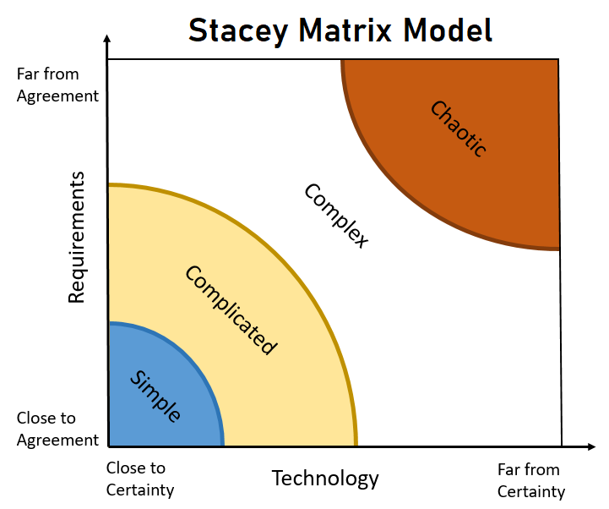

Ralph Stacey developed the Stacey matrix which is similar to the Cynefin framework, but it looks at two dimensions to determine the relative complexity of a project: (a) the relative uncertainty of the requirements for the deliverable, and (b) the relative uncertainty of the technology that will be used to

create the deliverable. Based on the relative uncertainty of these dimensions, a project is considered simple, complicated, complex, or chaotic. The degree of complexity is one factor that influences tailoring methods and practices for the project.

**3.2.5 Conflict Model**

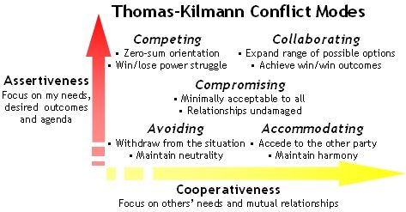

Conflict is common on projects. Conflict can be healthy and productive when handled well. It can result in greater trust among project team members and a deeper commitment to the outcomes. Fear of conflict can restrict communication and creativity. However, conflict can be unhealthy as well.

Addressing conflict inappropriately can lead to dissatisfaction, lack of trust, and reduced morale and motivation. The model based on work by Ken Thomas and Ralph Kilmann describes six ways of addressing conflict by focusing on the relative power between the individuals and the desire to maintain a good relationship as follows:-

* **Confronting/problem solving**:- Confronting a conflict treats the conflict as a problem to be solved. This style of conflict resolution is used when the relationship between parties is important, and when each person has confidence in the other party’s ability to problem-solve.
* **Collaborating**:- Collaborating involves incorporating multiple views about the conflict. The objective is to learn about the various views and see things from multiple perspectives. This is an effective method when there is trust among the participants and when there is time to come to consensus. A project manager may facilitate this type of conflict resolution between project team members.
* **Compromising**:- There are some conflicts in which all parties will not be fully satisfied. In those instances, finding a way to compromise is the best approach. Compromise entails a willingness to give and take. This allows all parties to get something they want, and it avoids escalating the conflict. This style is often used when the parties involved have equal “power.” A project manager may compromise with a technical manager regarding the availability of a project team member to work on the project.
* **Smoothing/accommodating**:- Smoothing and accommodating are useful when reaching the overarching goal is more important than the disagreement. This approach maintains harmony in the relationship and can create good will between the parties. This approach is also used when there is a difference in the relative authority or power of the individuals.

For example, this approach may be appropriate when there is a disagreement with the sponsor. Since the sponsor outranks the project manager or project team member, and there is a desire to maintain a good relationship with the sponsor, adopting an accommodating posture may be appropriate.

* **Forcing**:- Forcing is used when there is not enough time to collaborate or problem-solve. In this scenario, one party forces their will on the other. The party forcing has more power than the other party. A forcing style may be used if there is a health and safety conflict that needs to be resolved immediately.
* **Withdrawal/avoiding**:- Sometimes a problem will go away on its own, or sometimes discussions get heated and people need a cooling-off period. In both scenarios, withdrawing from the situation is appropriate. Withdrawal is also used in a no-win scenario, such as complying with a requirement imposed by a regulatory agency instead of challenging the requirement.

**3.3 Methods**

A method is a means for achieving an outcome, output, result, or project deliverable. The methods described here are a sampling of those commonly used to support project work. There are many methods that are not described here, either because they are used in project management the same way they are in other disciplines, such as interviewing, focus groups, checklists, and so forth, or because they are not frequently used across a broad spectrum of projects (i.e., the methods are industry specific).

Many of the methods are related by the purpose they serve, such as estimating or data gathering, and therefore, are presented in a group. Others are related by the type of activity involved, such as those in the meetings and analysis groups.

**Data Gathering Analysis**

Data gathering and analysis methods are used to collect, assess, and evaluate data and information to gain a deeper understanding of a situation. The outputs of data analysis may be organized and presented as one of the artifacts shown in Section. The data gathering and analysis methods described here, coupled with the artifacts described in, are often used to inform decisions.

* **Alternatives analysis**:-Alternatives analysis is used to evaluate identified options in order to select the options or approaches to perform the work of the project.
* **Assumption and constraint analysis**:- An assumption is a factor that is considered to be true, real, or certain, without proof or demonstration. A constraint is a limiting factor that affects the execution of a project, program, portfolio, or process. This form of analysis ensures that assumptions and constraints are integrated into the project plans and documents, and that there is consistency among them.
* **Benchmarking**: Benchmarking is the comparison of actual or planned products, processes, and practices to those of comparable organizations, which identifies best practices, generates ideas for improvement, and provides a basis for measuring performance.
* **Business justification analysis methods**:- This group of analysis methods is associated with authorizing or justifying a project or a decision. The outcomes of the following analyses are often used in a business case that justifies undertaking a project:

▹ ***Payback period****:-* The payback period is the time needed to recover an investment, usually in months or years.

▹ ***Internal rate of return (IRR)****:-* The internal rate of return is the projected annual yield of a project investment, incorporating both initial and ongoing costs into an estimated percentage growth rate a given project is expected to have.

▹ ***Return on investment (ROI):-***Return on investment is the percent return on an initial investment, calculated by taking the projected average of all net benefits and dividing them by the initial cost.

▹ ***Net present value (NPV)****:-* Net present value is the future value of expected benefits, expressed in the value those benefits have at the time of investment. NPV considers current and future costs and benefits and inflation.

▹ ***Cost-benefit analysis****:-* A cost-benefit analysis is a financial analysis tool used to determine the benefits provided by a project against its costs.

* **Check sheet**:-A check sheet is a tally sheet that can be used as a checklist when gathering data. Check sheets can be used to collect and segregate data into categories. Check sheets can also be used to create histograms and matrices as described in Section
* **Cost of quality**:- The cost of quality includes all costs incurred over the life of the product by investment in preventing nonconformance to requirements, appraisal of the product or service for conformance to requirements, and failure to meet requirements.
* **Decision tree analysis**:- A decision tree analysis is a diagramming and calculation method for evaluating the implications of a chain of multiple options in the presence of uncertainty. Decision trees can use the information generated from an expected monetary value analysis to populate the branches of the decision tree.
* **Earned value analysis**:- Earned value analysis is a method that utilizes a set of measures associated with scope, schedule, and cost to determine the cost and schedule performance of a project.
* **Expected monetary value (EMV)**:- The expected monetary value is the estimated value of an outcome expressed in monetary terms. It is used to quantify the value of uncertainty, such as a risk, or compare the value of alternatives that are not necessarily equivalent. The EMV is calculated by multiplying the probability that an event will occur and the economic impact the event would have should it occur.
* **Forecast**:- A forecast is an estimate or prediction of conditions and events in the project’s future, based on information and knowledge available at the time of the forecast. Qualitative forecasting methods use the opinions and judgments of subject matter experts. Quantitative forecasting uses models where past information is used to predict future performance. Causal or econometric forecasting, such as regression analysis, identifies variables that can have significant impact on future outcomes.
* **Influence diagram**:- This diagram is a graphical representation of situations showing causal influences, time ordering of events, and other relationships among variables and outcomes.
* **Life cycle assessment**:- This assessment is a tool used to evaluate the total environmental impact of a product, process, or system. It includes all aspects of producing a project deliverable, from the origin of materials used in the deliverable to its distribution and ultimate disposal.
* **Make-or-buy analysis**:- A make-or-buy analysis is the process of gathering and organizing data about product requirements and analysing them against available alternatives such as the purchase versus internal manufacture of the product.
* **Probability and impact matrix**:- A probability and impact matrix is a grid for mapping the probability of occurrence of each risk and its impact on project objectives if that risk occurs.
* **Process analysis**:- This analysis is a systematic review of the steps and procedures to perform an activity.
* **Regression analysis**:- A regression analysis is an analytical technique where a series of input variables are examined in relation to their corresponding output results in order to develop a mathematical or statistical relationship.
* **Reserve analysis**:- This analytical technique is used to evaluate the amount of risk on the project and the amount of schedule and budget reserve to determine whether the reserve is sufficient for the remaining risk. The reserve contributes to reducing risk to an acceptable level.
* **Root cause analysis**:- This analytical technique is used to determine the basic underlying cause of a variance, defect, or a risk. A root cause may underlie more than one variance, defect, or risk.
* **Sensitivity analysis**:- This analytical technique is used to determine which individual project risks or other sources of uncertainty have the most potential impact on project outcomes by correlating variations in project outcomes with variations in elements of a quantitative risk analysis model.
* **Simulations**:- This analytical technique uses models to show the combined effect of uncertainties in order to evaluate their potential impact on objectives. A Monte Carlo simulation is a method of identifying the potential impacts of risk and uncertainty using multiple iterations of a computer model to develop a probability distribution of a range of outcomes that could result from a decision or course of action.
* **Stakeholder analysis**:- This technique involves systematically gathering and analyzing quantitative and qualitative information about stakeholders to determine whose interests should be taken into account throughout the project.
* **SWOT analysis**:- A SWOT analysis assesses the strengths, weaknesses, opportunities, and threats of an organization, project, or option.
* **Trend analysis**:- A trend analysis uses mathematical models to forecast future outcomes based on historical results.
* **Value stream mapping**:- Value stream mapping is a lean enterprise method used to document, analyze, and improve the flow of information or materials required to produce a product or service for a customer.
* **Variance analysis**:- Variance analysis is used to determine the cause and degree of difference between the baseline and actual performance.
* **What-if scenario analysis**:- This analytical technique evaluates scenarios in order to predict their effect on project objectives.

**Estimating**

Estimating methods are used to develop an approximation of work, time, or cost on a project.

* **Affinity grouping**:- Affinity grouping involves classifying items into similar categories or collections on the basis of their likeness. Common affinity groupings include T-shirt sizing and Fibonacci numbers.
* **Analogous estimating**. Analogous estimating assesses the duration or cost of an activity or a project using historical data from a similar activity or project.
* **Function point**:- A function point is an estimate of the amount of business functionality in an information system. Function points are used to calculate a functional size measurement (FSM) of a software system.
* **Multipoint estimating**:- Multipoint estimating assesses cost or duration by applying an average or weighted average of optimistic, pessimistic, and most likely estimates when there is uncertainty with the individual activity estimates.
* **Parametric estimating**:- Parametric estimating uses an algorithm to calculate cost or duration based on historical data and project parameters.
* **Relative estimating**:- Relative estimating is used to create estimates that are derived from performing a comparison against a similar body of work, taking effort, complexity, and uncertainty into consideration. Relative estimating is not necessarily based on absolute units of cost or time. Story points are a common unitless measure used in relative estimating.
* **Single-point estimating**:- Single-point estimating involves using data to calculate a single value that reflects a best-guess estimate. A single-point estimate is opposed to a range estimate, which includes the best- and worst-case scenario.
* **Story point estimating**:- Story point estimating involves project team members assigning abstract, but relative, points of effort required to implement a user story. It tells the project team about the difficulty of the story considering the complexity, risks, and effort involved.
* **Wideband Delphi**:- Wideband Delphi is a variation of the Delphi estimating method where subject matter expert’s complete multiple rounds of producing estimates individually, with a project team discussion after each round, until a consensus is achieved. For Wideband Delphi, those who created the highest and lowest estimates explain their rationale, following which everyone re-estimates. The process repeats until convergence is achieved. Planning poker is a variation of Wideband Delphi.

**Meetings and Events**

Meetings are an important means for engaging the project team and other stakeholders. They

are a primary means of communication throughout the project.

* **Backlog refinement**:- At a backlog refinement meeting, the backlog is progressively elaborated and (re)prioritized to identify the work that can be accomplished in an upcoming iteration.
* **Bidder conference**:- Meetings with prospective sellers prior to the preparation of a bid or proposal to ensure all prospective vendors have a clear and common understanding of the procurement. This meeting may also be known as contractor conferences, vendor conferences, or pre-bid conferences.
* **Change control board**:- A change control board meeting includes the group of people who are accountable for reviewing, evaluating, approving, delaying, or rejecting changes to the project. The decisions made at this meeting are recorded and communicated to the appropriate stakeholders. This meeting may also be referred to as a change control meeting.
* **Daily Stand-up**:- A stand-up is a brief collaboration meeting during which the project team reviews its progress from the previous day, declares intentions for the current day, and highlights any obstacles encountered or anticipated. This meeting may also be referred to as a daily scrum.
* **Iteration planning**:- An iteration planning meeting is used to clarify the details of the backlog items, acceptance criteria, and work effort required to meet an upcoming iteration commitment. This meeting may also be referred to as a sprint planning meeting.
* **Iteration review**:- An iteration review is held at the end of an iteration to demonstrate the work that was accomplished during the iteration. This meeting may also be referred to as a sprint review.
* **Kick-off**:- A kick-off meeting is a gathering of project team members and other key stakeholders at the outset of a project to formally set expectations, gain a common understanding, and commence work. It establishes the start of a project, phase, or iteration.
* **Lessons learned meeting**:- A lessons learned meeting is used to identify and share the knowledge gained during a project, phase, or iteration with a focus on improving project team performance. This meeting can address situations that could have been handled better in addition to good practices and situations that produced very favourable outcomes.
* **Planning meeting**:- A planning meeting is used to create, elaborate, or review a plan or plans and secure commitment for the plan(s).
* **Project closeout**:- A project closeout meeting is used to obtain final acceptance of the delivered scope from the sponsor, product owner, or client. This meeting indicates that the product delivery is complete.
* **Project review**:- A project review meeting is an event at the end of a phase or a project to assess the status, evaluate the value delivered, and determine if the project is ready to move to the next phase, or transition to operations.
* **Release planning**:- Release planning meetings identify a high-level plan for releasing or transitioning a product, deliverable, or increment of value.
* **Retrospective**:- A retrospective is a regularly occurring workshop in which participants explore their work and results in order to improve both process and product. Retrospectives are a form of lessons learned meeting.
* **Risk review**:- A meeting to analyze the status of existing risks and identify new risks. This includes determining if the risk is still active and if there have been changes to the risk attributes (such as probability, impact, urgency, etc.). Risk responses are evaluated to determine if they are effective or should be updated. New risks may be identified and analysed and risks that are no longer active may be closed. Risk reassessment is an example of a risk-review meeting.
* **Status meeting**:- A status meeting is a regularly scheduled event to exchange and analyze information about the current progress of the project and its performance.
* **Steering committee**:- A meeting where senior stakeholders provide direction and support to the project team and make decisions outside of the project team’s authority.

**Other Methods**

The methods described in this section don’t fit into a specific category; however, they are

common methods that are used for a variety of purposes on projects.

* **Impact mapping**:- Impact mapping is a strategic planning method that serves as a visual

roadmap for the organization during product development.

* **Modelling**:- Modelling is the process of creating simplified representations of systems,

solutions, or deliverables such as prototypes, diagrams, or storyboards. Modeling can

facilitate further analysis by identifying gaps in information, areas of miscommunication,

or additional requirements.

* **Net Promoter Score (NPS®):-** An index that measures the willingness of customers to

recommend an organization’s products or services to others. The score is used as a proxy

for gauging the customer’s overall satisfaction with an organization’s product or service

and the customer’s loyalty to the brand.

* **Prioritization schema**:- Prioritization schema are methods used to prioritize portfolio,

program, or project components, as well as requirements, risks, features, or other product

information. Examples include a multicriteria weighted analysis and the MoSCoW (must

have, should have, could have, and won’t have) method.

* **Timebox**:- A timebox is a short, fixed period of time in which work is to be completed,

such as 1 week, 2 weeks, or 1 month.

**Methods applied across Performance Domains**

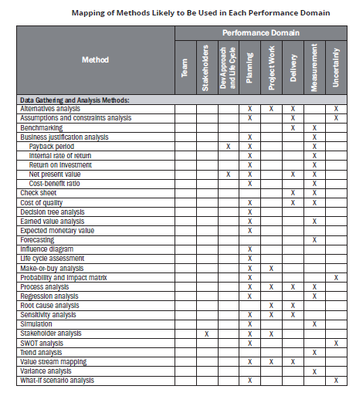

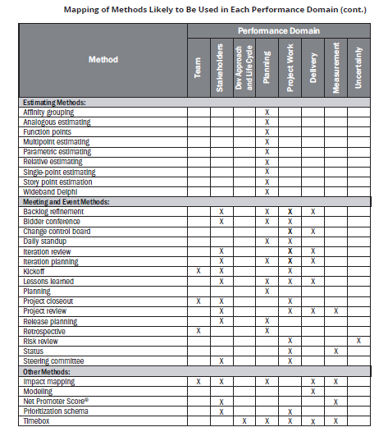

**3.4 Artifacts**

An artifact is a template, document, output, or project deliverable. There are many documents or deliverables that are not described here, either because (a) they are somewhat generic, such as updates; (b) they are industry specific; or (c) they are a result of a specific method that was used to create it. For example, while cost estimates are an important artifact, they are the result of various estimating methods.

**Strategy Artifacts**

Documents that are created prior to or at the start of the project that address strategic, business, or high-level information about the project. Strategy artifacts are developed at the start of a project and do not normally change, though they may be reviewed throughout the project.

* **Business case**:- A business case is a value proposition for a proposed project that may include financial and nonfinancial benefits.
* **Business model canvas**:- This artifact is a one-page visual summary that describes the value proposition, infrastructure, customers, and finances. These are often used in lean start-up situations.
* **Project brief**:- A project brief provides a high-level overview of the goals, deliverables, and processes for the project.
* **Project charter**:- A project charter is a document issued by the project initiator or sponsor that formally authorizes the existence of a project and provides the project manager with the authority to apply organizational resources to project activities.
* **Project vision statement**:- This document is a concise, high-level description of the project that states the purpose, and inspires the project team to contribute to the project.
* **Roadmap**:- This document provides a high-level time line that depicts milestones, significant events, reviews, and decision points.

**Logs & Registers**

Logs and registers are used to record continuously evolving aspects of the project. They are updated throughout the project. The terms log and register are sometimes used interchangeably. It is not uncommon to see the term *risk register* or *risk log* referring to the same artifact.

* **Assumption log**:- An assumption is a factor that is considered to be true, real, or certain, without proof or demonstration. A constraint is a factor that limits the options for managing a project, program, portfolio, or process. An assumption log records all assumptions and constraints throughout the project.
* **Backlog**:- A backlog is an ordered list of work to be done. Projects may have a product backlog, a requirements backlog, impediments backlog, and so forth. Items in a backlog are prioritized. The prioritized work is then scheduled for upcoming iterations.
* **Change log**:- A change log is a comprehensive list of changes submitted during the project and their current status. A change can be a modification to any formally controlled deliverable, project management plan component, or project document.
* **Issue log**:- An issue is a current condition or situation that may have an impact on the project objectives. An issue log is used to record and monitor information on active issues. Issues are assigned to a responsible party for follow up and resolution.
* **Lessons learned register**:- A lessons learned register is used to record knowledge gained during a project, phase, or iteration so that it can be used to improve future performance for the project team and/or the organization.
* **Risk-adjusted backlog**:- A risk-adjusted backlog is a backlog that includes work and actions to address threats and opportunities.
* **Risk register**:- A risk register is a repository in which outputs of risk management processes are recorded. Information in a risk register can include the person responsible for managing the risk, probability, impact, risk score, planned risk responses, and other information used to get a high-level understanding of individual risks.
* **Stakeholder register**:- A stakeholder register records information about project stakeholders, which includes an assessment and classification of project stakeholders.

**Plans**

A plan is a proposed means of accomplishing something. Project teams develop plans for individual aspects of a project and/or combine all of that information into an overarching project management plan. Plans generally are written documents but may also be reflected on visual/ virtual whiteboards.

* **Change control plan**:- A change control plan is a component of the project management plan that establishes the change control board, documents the extent of its authority, and describes how the change control system will be implemented.
* **Communications management plan**:- This plan is a component of the project, program, or portfolio management plan that describes how, when, and by whom information about the project will be administered and disseminated.
* **Cost management plan**:- This plan is a component of a project or program management plan that describes how costs will be planned, structured, and controlled.
* **Iteration plan**:- This plan is a detailed plan for the current iteration.
* **Procurement management plan**:- This plan is a component of the project or program management plan that describes how a project team will acquire goods and services from outside of the performing organization.
* **Project management plan**:- The project management plan is a document that describes how the project will be executed, monitored and controlled, and closed.
* **Quality management plan**:- This plan is a component of the project or program management plan that describes how applicable policies, procedures, and guidelines will be implemented to achieve the quality objectives.
* **Release plan**:- This plan sets expectations for the dates, features, and/or outcomes expected to be delivered over the course of multiple iterations.
* **Requirements management plan**:- This plan is a component of the project or program management plan that describes how requirements will be analyzed, documented, and managed.
* **Resource management plan**:- This plan is a component of the project management plan that describes how project resources are acquired, allocated, monitored, and controlled.
* **Risk management plan**:- This plan is a component of the project, program, or portfolio management plan that describes how risk management activities will be structured and performed.
* **Scope management plan**:- This plan is a component of the project or program management plan that describes how the scope will be defined, developed, monitored, controlled, and validated.
* **Schedule management plan**:- This plan is a component of the project or program management plan that establishes the criteria and the activities for developing, monitoring, and controlling the schedule.
* **Stakeholder engagement plan**:- This plan is a component of the project management plan that identifies the strategies and actions required to promote productive involvement of stakeholders in project or program decision making and execution.
* **Test plan**:- This document describes deliverables that will be tested, tests that will be conducted, and the processes that will be used in testing. It forms the basis for formally testing the components and deliverables.

**Hierarchy Charts**

Hierarchy charts begin with high-level information that is progressively decomposed into greater levels of detail. The information at the upper levels encompasses all the information at the lower or subsidiary levels. Hierarchy charts are often progressively elaborated into greater levels of detail as more information is known about the project.

* **Organizational breakdown structure**:- This chart is a hierarchical representation of the

project organization, which illustrates the relationship between project activities and the

organizational units that will perform those activities.

* **Product breakdown structure**:- This chart is a hierarchical structure reflecting a product’s

components and deliverables.

* **Resource breakdown structure**:- This chart is a hierarchical representation of resources

by category and type.

* **Risk breakdown structure**:- This chart is a hierarchical representation of potential

sources of risks.

* **Work breakdown structure**:- This chart is a hierarchical decomposition of the total

scope of work to be carried out by the project team to accomplish the project objectives

and create the required deliverables.

**Baselines**

A baseline is the approved version of a work product or plan. Actual performance is compared

to baselines to identify variances.

* **Budget**:- A budget is the approved estimate for the project or any work breakdown structure (WBS) component or any schedule activity.
* Milestone schedule. This type of schedule presents milestones with planned dates.
* **Performance measurement baseline**:- Integrated scope, schedule, and cost baselines are used for comparison to manage, measure, and control project execution.
* **Project schedule**:- A project schedule is an output of a schedule model that presents linked activities with planned dates, durations, milestones, and resources.
* **Scope baseline**:- This baseline is the approved version of a scope statement, work breakdown structure (WBS), and its associated WBS dictionary that can be changed using formal change control procedures and is used as the basis for comparison to actual results.

**Visual Data & Information**

Visual data and information are artifacts that organize and present data and information in a visual format, such as charts, graphs, matrices, and diagrams. Visualizing data makes it easier to absorb data and turn it into information. Visualization artifacts are often produced after data have been collected and analyzed. These artifacts can aid in decision making and prioritization.

* **Affinity diagram**:- This diagram shows large numbers of ideas classified into groups for review and analysis.
* **Burndown/burnup chart**:- This chart is a graphical representation of the work remaining in a timebox or the work completed toward the release of a product or project deliverable.
* **Cause-and-effect diagram**:- This diagram is a visual representation that helps trace an undesirable effect back to its root cause.
* **Cumulative flow diagram (CFD)**:- This chart indicates features completed over time, features in development, and those in the backlog. It may also include features at intermediate states, such as features designed but not yet constructed, those in quality assurance, or those in testing.
* **Cycle time chart**:- This diagram shows the average cycle time of the work items completed over time. A cycle time chart may be shown as a scatter diagram or a bar chart.
* **Dashboards**:- This set of charts and graphs shows progress or performance against important measures of the project.
* **Flowchart**:- This diagram depicts the inputs, process actions, and outputs of one or more processes within a system.
* **Gantt chart**:- This bar chart provides schedule information where activities are listed on the vertical axis, dates are shown on the horizontal axis, and activity durations are shown as horizontal bars placed according to start and finish dates.
* **Histogram**:- This bar chart shows the graphical representation of numerical data.
* **Information radiator**:- This artifact is a visible, physical display that provides information to the rest of the organization, enabling timely knowledge sharing.
* **Lead time chart**:-This diagram shows the trend over time of the average lead time of the items completed in work. A lead time chart may be shown as a scatter diagram or a bar chart.
* **Prioritization matrix**:- This matrix is a scatter diagram where effort is shown on the horizontal axis and value on the vertical axis, divided into four quadrants to classify items by priority.
* **Project schedule network diagram**:- This graphical representation shows the logical relationships among the project schedule activities.
* **Requirements traceability matrix**:- This matrix links product requirements from their origin to the deliverables that satisfy them.
* **Responsibility assignment matrix (RAM)**:- This matrix is a grid that shows the project resources assigned to each work package. A RACI chart is a common way of showing stakeholders who are responsible, accountable, consulted, or informed and are associated with project activities, decisions, and deliverables.
* **Scatter diagram**:- This graph shows the relationship between two variables.
* **S-curve**:- This graph displays cumulative costs over a specified period of time.
* **Stakeholder engagement assessment matrix**:- This matrix compares current and desired stakeholder engagement levels.
* **Story map**:- A story map is a visual model of all the features and functionality desired for a given product, created to give the project team a holistic view of what they are building and why.
* **Throughput chart**:- This chart shows the accepted deliverables over time. A throughput chart may be shown as a scatter diagram or a bar chart.
* **Use case**:- This artifact describes and explores how a user interacts with a system to achieve a specific goal.
* **Value stream map**:- This is a lean enterprise method used to document, analyze, and improve the flow of information or materials required to produce a product or service for a customer. Value stream maps can be used to identify waste.
* **Velocity chart**:- This chart tracks the rate at which the deliverables are produced, validated, and accepted within a predefined interval.

**Reports**

Reports are formal records or summaries of information. Reports communicate relevant (usually summary level) information to stakeholders. Often reports are given to stakeholders who are interested in the project status, such as sponsors, business owners, or PMOs.

* **Quality report**:- This project document includes quality management issues, recommendations for corrective actions, and a summary of findings from quality control activities. It may include recommendations for process, project, and product improvements.
* **Risk report**:- This project document is developed progressively throughout the risk management processes and summarizes information on individual project risks and the level of overall project risk.
* **Status report**:- This document provides a report on the current status of the project. It may include information on progress since the last report and forecasts for cost and schedule performance.

An **agreement** is any document or communication that defines the intentions of the parties. In projects, agreements take the form of contracts or other defined understandings.

A **contract** is a mutually binding agreement that obligates the seller to provide the specified product, service, or result and obligates the buyer to pay for it. There are different types of contracts, some of which fall within a category of fixed-price or cost-reimbursable contracts.

* **Fixed-price contracts**:- This category of contract involves setting a fixed price for a well-defined product, service, or result. Fixed-price contracts include firm fixed price (FFP), fixed-price incentive fee (FPIF), and fixed price with economic price adjustment (FP-EPA), among others.
* **Cost-reimbursable contract**:-. This category of contracts involves payments to the seller for actual costs incurred for completing the work plus a fee representing seller profit. These contracts are often used when the project scope is not well defined or is subject to frequent change. Cost-reimbursable contracts include cost plus award fee (CPAF), cost plus fixed fee (CPFF), and cost plus incentive fee (CPIF).
* **Time and materials (T&M)**:- This contract establishes a fixed rate, but not a precise statement of work. It can be used for staff augmentation, subject matter expertise, or other outside support.
* Indefinite delivery indefinite quantity (IDIQ):- This contract provides for an indefinite quantity of goods or services, with a stated lower and upper limit, and within a fixed time period. These contracts can be used for architectural, engineering, or information technology engagements.
* **Other agreements**:- Other types of agreements include memorandum of understanding (MOU), memorandum of agreement (MOA), service level agreement (SLA), basic ordering agreement (BOA), among others.

**Other Artifacts**

The documents and deliverables described here do not fit into a specific category; however,

they are important artifacts that are used for a variety of purposes.

* **Activity list**:- This document provides a tabulation of schedule activities that shows the activity description, activity identifier, and a sufficiently detailed scope of work description so project team members understand what work is to be performed.
* **Bid documents**:- Bid documents are used to request proposals from prospective sellers. Depending on the goods or services needed, bid documents can include, among others:

▹ Request for information (RFI),

▹ Request for quotation (RFQ), and

▹ Request for proposal (RFP).

* **Metrics**:- Metrics describe an attribute and how to measure it.
* **Project calendar**:- This calendar identifies working days and shifts that are available

for scheduled activities.

* **Requirements documentation**:- This document is a record of product requirements and

relevant information needed to manage the requirements, which includes the associated

category, priority, and acceptance criteria.

* **Project team charter**:- This document records the project team values, agreements,

and operating guidelines, and establishes clear expectations regarding acceptable behavior

by project team members.

* **User story**:- A user story is a brief description of an outcome for a specific user, which

is a promise of a conversation to clarify details.

**Artifacts applied across Performance Domains**

Different artifacts are more likely to be useful in different performance domains. While the delivery approach, product, and organizational environment will determine which artifacts are most applicable for a specific project, there are some performance domains that are more likely to make use of specific artifacts.

